SmartSpend: An AI-Assisted Mobile Financial Tracking and Advisory Application for Personal Financial Management

A CAPSTONE Project
presented to the faculty of the
College of Computer Studies and Engineering
LORMA Colleges

In Partial Fulfillment
of the requirements for the degree
of Bachelor of Science in Information Technology

by:
Brix A. Directo
Cyrille John M. Rubis
Djaunathan Albert S. Madayag
Ellen Flores Mangaoang, DIT

November 2026
APPROVAL SHEET

This is to certify that we have supervised the preparation of the Capstone Project and read the manuscript prepared by DIRECTO, BRIX A., RUBIS, CYRILLE JOHN M., and MADAYAG, DJAUNATHAN ALBERT S. entitled SMARTSPEND: AN AI-ASSISTED MOBILE FINANCIAL TRACKING AND ADVISORY APPLICATION FOR PERSONAL FINANCIAL MANAGEMENT and that the said capstone project has been submitted for final examination by the Oral Examination Committee.

Ellen F. Mangaoang, DIT
Capstone Project Adviser
Shekiro R. Raposas, MTS, MIS
Capstone Teacher-in-Charge

As members of the Oral Examination Committee, we certify that we have examined this capstone project presented before the committee and hereby recommend that it be accepted in partial fulfillment of the capstone requirements for the degree in Bachelor of Science in Information Technology.

_______________________________
Jeoffrey B. Layco, MIS
Chairperson

_________________ _________________
Shekiro R. Raposas, MTS, MIS Mary-Ann Mzana, MTS
Member Member

This capstone project is hereby approved and accepted by the College of Computer Studies and Engineering in partial fulfillment of the requirements for the degree in Bachelor of Science in Information Technology.

_______________________________
Jeoffrey B. Layco, MIS
Dean, CCSE

ABSTRACT
Financial mismanagement remained a critical and documented challenge among Filipino households, compounded by limited access to accessible, localized, and intelligent financial tools. This study aimed to: (1) assess the financial management practices, budgeting challenges, and expense-tracking behaviors of parents aged 35–55 and young professionals aged 21–35 in San Fernando City, La Union; (2) design and develop SmartSpend, an AI-assisted mobile financial tracking and advisory application for Android; and (3) evaluate the usability of the developed system using the System Usability Scale (SUS).
The study employed a quantitative descriptive developmental research design. A validated survey questionnaire was administered to assess financial practices and technology acceptance. SmartSpend was developed using an Agile Kanban methodology, integrating a multi-provider large language model (LLM) architecture with Gemini 3.5 Flash-Lite as the primary model, enabling 34 autonomous financial management actions. Usability was evaluated using the 10-item Brooke (1996) SUS instrument administered after respondents used the application for at least 10 minutes.
The needs assessment revealed that 96.7% of respondents expressed positive intent to use an AI-powered financial application, and 93.3% already used GCash, validating the target features. SmartSpend version 3.1.0 was successfully developed as an offline-first Android application with multi-modal expense input, a Financial Health Score (FHS) formally classified as a Prototype Observed Financial Health Indicator, and an eight-provider cloud failover chain (Gemini 3.5 Flash-Lite as primary, seven fallbacks). Usability evaluation yielded a mean SUS score of 61.83 (SD = 17.58), corresponding to a grade of D and an adjective rating of "OK" under the Bangor et al. (2009) scale below the 68-point benchmark (Sauro & Lewis, 2016) and the pre-established target of 80.
The results indicated that SmartSpend showed promise as a prototype AI-assisted financial tool for the target demographic, though the below-target usability score highlighted areas for UI/UX refinement. The study contributed a locally contextualized, evaluated prototype that addressed gaps in existing Philippine personal finance applications, particularly the absence of Filipino-English LLM integration, offline-first operation, and behavioral health scoring. Nine recommendations were identified for future development, including UI/UX refinement, a backend API proxy, on-device AI, SQLite encryption, formal parsing evaluation, and a longitudinal study.
ACKNOWLEDGEMENT
The researchers wished to express their sincere gratitude and appreciation to all the individuals who contributed to the successful completion of this study.
First and foremost, the researchers thanked the Almighty God for His guidance, strength, wisdom, and blessings throughout the entire process of this research. His presence had been a source of hope and perseverance in overcoming challenges.
The researchers extended their heartfelt appreciation to the Dean of the College of Computer Studies and Engineering, Mr. Jeoffrey B. Layco, for his leadership and support in fostering an environment conducive to academic growth.
Special thanks were given to their capstone adviser, Dr. Ellen F. Mangaoang, for the invaluable guidance, patience, and knowledge shared throughout the development of this study. The adviser’s insights and support played a significant role in shaping the direction and quality of this research.
The researchers also wished to thank their instructor in charge, Mr. Shekiro R. Raposas, MTS, MIS, for providing direction, structure, and continuous reminders that helped ensure the completion of all requirements.
To the panelists Mr. Jeoffrey B. Layco, MIS, Mr. Shekiro R. Raposas, MTS, MIS, and Ms. Mary-Ann Mzana, MTS, the researchers expressed their gratitude for their time, effort, and constructive feedback, which greatly contributed to improving the study.
The researchers also acknowledged the College of Computer Studies and Engineering Department for equipping them with the necessary knowledge and skills in the field of Information Technology.
Finally, the researchers extended their deepest gratitude to their families and friends for their unwavering support, encouragement, and understanding throughout this journey. Their motivation and belief had been a constant source of strength.

The Researchers

DEDICATION
This study was dedicated to the people who had been a constant source of inspiration, support, and strength throughout this journey.
First and foremost, the researchers dedicated this work to their beloved parents, whose unconditional love, sacrifices, and encouragement had been the foundation of their perseverance. Their guidance and belief in the researchers made this achievement possible.
The researchers also dedicated this study to their friends and classmates, whose support, shared experiences, and encouragement helped make this journey more meaningful and manageable.
To their mentors and instructors, this work was also dedicated in appreciation of the knowledge, guidance, and inspiration they had provided throughout the researchers’ academic journey.
Lastly, this study was dedicated to future researchers who might build upon this work and continue advancing the field of information technology and financial systems.
BAD
CJMR
DASM
TABLE OF CONTENTS
Page
Title Page i
Approval Sheet ii
Acknowledgement iii
Dedication iv
Table of Contents v
List of Figures vi
Figure 1: Financial Literacy Rates by Demographic Group (BSP, 2021; Inquiro, 2024).
Figure 2: Conceptual Framework (Mobile Application)
Figure 3: System Usability Scale (SUS) Score Interpretation
Figure 4: Agile Kanban Workflow for SmartSpend Development
Figure 5: Demographic Distribution of Needs-Assessment Respondents (N = 30).
Figure 6: SmartSpend System Flowchart
Figure 7: Use Case Diagram
Figure 8: Visual Table of Contents
Figure 9: Login and Demo Mode Screen
Figure 10: Home Dashboard
Figure 11: Expense Logging Through Peso Chat
Figure 12: Receipt Scanning and Batch Screenshot Import
Figure 13: Financial Health Score Breakdown
Figure 14: Budgets, Safe-to-Spend, and Savings Goals
Figure 15: Local AI Mode Setup
Figure 16: SUS Computation Table
List of Tables vii
Table 1: Three-Level Gap Analysis of SmartSpend
Table 2: Feature Comparison of SmartSpend with Existing Financial Applications (including Filipino-context apps)
Table 3: Distribution of Respondents and Validators
Table 4: Agile Kanban Workflow Phases and Deliverables
Table 6: Demographic Profile and Expense Tracking Methods of Respondents (N = 30)
Table 7: Comparative Evaluation of LLM APIs for SmartSpend Integration
Table 8: Overall SUS Result
Table 9: System Usability Scale (SUS) Results by Respondent Group

INTRODUCTION
CHAPTER I – Introduction
Project Context
Conceptual Framework
Statement of Objectives
Scope and Limitations of the Study
Purpose and Description
Technical Background
CHAPTER II – Design and Methodology
Research Design
Population and Locale
Ethical Considerations
Data Gathering Tools and Procedure
Software Methodology
CHAPTER III – Results and Discussion
Assessment of Financial Management Practices, Budgeting Challenges, and Expense Tracking Behaviors
Design and Development of the SmartSpend Mobile Application
Overview of the System
Determined the Usability of SmartSpend Using the System Usability Scale
CHAPTER IV – Conclusions and Recommendations
Conclusions
Recommendations
References

Chapter I

INTRODUCTION
This chapter presented the background of the study, including the context and motivation for developing the SmartSpend mobile application. It also discussed the objectives of the research, scope and limitations of the system, and its intended purpose and users. In addition, this chapter outlined the conceptual framework that guided the system design, as well as the technical background of the technologies used in the development of the developed AI-powered financial assistant.

Project Context
Financial mismanagement was a documented and pressing problem in the Philippines. According to the 2021 Bangko Sentral ng Pilipinas (BSP) Financial Inclusion Survey, only 2% of Filipino adults correctly answered all six basic financial literacy questions covering numeracy, interest rates, inflation, and risk while fewer than half reported maintaining any household or personal budget (Bangko Sentral ng Pilipinas, 2021). The Philippine Statistics Authority Family Income and Expenditure Survey (PSA FIES, 2021) further revealed that a substantial proportion of Filipino households spent beyond their monthly income, with recurring expenditures on food, transportation, and utilities consistently outpacing savings. In Filipino households, parents aged 35 to 55 typically served as primary financial decision-makers, managing budgeting, bill payments, and daily expenses, yet national survey data indicated that many adults still lack formal financial accounts and did not maintain written budgets, leaving household finances managed without structured tools or guidance (Bangko Sentral ng Pilipinas, 2021; Philippine Statistics Authority, 2021). Despite high mobile phone penetration in the country and growing global mobile app adoption (Statista, 2024), most Filipinos did not use structured financial management tools, citing manual effort, poor local language support, and lack of meaningful feedback as primary barriers to adoption (BSP, 2021; World Bank, 2022). Secondary analyses estimated that only around one in four Filipino adults met international financial literacy benchmarks far below neighboring countries such as Malaysia and Singapore where rates exceeded 50% (Inquiro, 2024).
More recent data suggested this picture was beginning to shift, though unevenly. BSP's newer, annual Consumer Finance and Inclusion Survey (CFIS) 2025 reported that 74% of Filipinos now correctly answered basic financial literacy questions, up from 69% in 2021, alongside a reported decline in informal borrowing (Bangko Sentral ng Pilipinas, 2025). The same survey reported formal account ownership actually fell to 50% of adults, down from 56% in 2021 even as BSP's related Consumer Expectations Survey found household-level financial access rising to 85%, up from 74% in 2024 suggesting access was broadening at the household level while individual account ownership and structured budgeting habits remained uneven. This mixed picture, rather than a resolved problem, remained the motivation for this study.
Several studies and reports highlighted persistent challenges in personal financial management among Filipino households. National financial inclusion surveys reported that many adults had difficulty maintaining formal budgets, tracking expenses consistently, and building emergency savings, particularly in lower-income and older age groups (Bangko Sentral ng Pilipinas, 2021). These challenges were compounded by volatile prices, rising living costs, and the prevalence of informal credit arrangements, such as borrowing from relatives or neighborhood stores, which were often not recorded systematically in any tool or system (Philippine Statistics Authority, 2021; Flores, 2025).
A study on the financial freedom of Filipino workers further revealed pervasive literacy challenges, including reliance on traditional saving methods, high debt dependence, and a 'come-what-may' attitude toward financial planning all of which contributed to weak financial resilience among Filipino households (Flores, 2025).
In the context of everyday life, parents and working adults frequently juggled multiple roles, including employment, caregiving, and managing household responsibilities. This left limited time and mental energy for manual expense recording or detailed financial planning. Traditional approaches, such as notebooks, spreadsheets, and simple expense trackers, relied heavily on user discipline and did not provide proactive feedback when spending patterns became risky. As a result, many users abandoned these tools after an initial trial period, leading to incomplete records and a lack of useful historical data for decision-making (Stefanov et al., 2024; Flores, 2025).

Figure 1: Financial Literacy Rates by Demographic Group (BSP, 2021; Inquiro, 2024).
Figure 1 presents the financial literacy rates across demographic groups in the Philippines, based on data from BSP (2021) and Inquiro (2024). The chart shows that literacy rates vary significantly by age group and income level, highlighting the gap that SmartSpend aimed to address for parents aged 35–55 and young professionals aged 21–35.
Globally, a variety of personal finance applications had emerged, including zero-based budgeting tools, multi-account financial dashboards, and AI-assisted expense trackers. However, many of these systems were designed for markets with widespread bank connectivity and higher levels of financial literacy, and they often depended on direct bank integration or credit card data feeds (Stefanov et al., 2024). In the Philippine context, existing applications and local solutions addressed specific aspects of financial management but still lacked integrated conversational AI, spending behavior analysis, and health scoring tailored to Filipino users who relied on mixed payment methods such as cash, e-wallets, and informal credit (Bangko Sentral ng Pilipinas, 2021; Stefanov et al., 2024). At the demographic level, parents and young professionals might download budgeting apps but discontinued use when the effort of manual encoding was perceived as too high and when warnings could be ignored without visible consequences for their financial standing. Table 1 presented a three-level summary of the identified gaps and SmartSpend's corresponding solutions.
Table 1: Three-Level Gap Analysis of SmartSpend
Gap Level | Existing Problem | SmartSpend Solution
International | Manual entry dominated; AI categorization degraded for non-English transactions (Stefanov et al., 2024) | LLM-based parsing for Filipino-English natural language input
National (PH) | Local apps lacked LLM chat, spending behavior analysis, and health scoring (Bangko Sentral ng Pilipinas, 2021; Stefanov et al., 2024) | Conversational AI + Financial Health Score + multi-period summaries
Demographic | Parents abandoned apps due to manual effort; warnings were ignored without consequences (BSP, 2021) | Automated input + score decay consequence system
Several existing applications demonstrated how mobile tools could support personal financial management but also revealed gaps that SmartSpend intended to address. Tarsi – Budget Tracker, a recently introduced application available in the Philippine App Store, supported offline expense tracking, receipt image capture, and category-based summaries, which made it suitable for users who preferred manual or semi-automatic tracking (Tarsi – Budget Tracker, 2026). However, it did not provide a conversational assistant that could interpret natural language commands, nor did it compute a unified financial health score that reflected overall budgeting behavior. YNAB (You Need A Budget) implemented a zero-based envelope budgeting method that was effective for debt payoff planning, but required manual entry and a subscription cost that might have been less accessible to Filipino users (Yomio, 2026). Monarch Money offered multi-account aggregation and net worth tracking but was designed for bank-connected markets and did not support offline functionality or Filipino locale inputs. Copilot provided AI-based expense categorization but was limited to iOS and did not support Filipino-English voice or OCR input. PocketGuard simplified available spending into a single daily figure but lacked spending behavior analysis, health scoring, or multi-modal input. These comparisons demonstrated the value of existing digital financial tools but confirmed that there was still room for a localized solution that combined offline capability, multi-modal expense input, and an accessible behavioral scoring mechanism. Table 2 summarized the key feature differences.
Beyond the applications summarized in Table 2, several other Philippine-context finance apps competed in this space and were acknowledged here rather than treated as a gap SmartSpend uniquely filled. Agila: Finance Coach added a business profile (invoices, inventory, collections) on top of personal tracking, with offline-first storage and no mandatory account (Agila: Finance Coach, 2026); PISO Budget Tracker offered fully offline, ad-free, payday-cycle budgeting (PISO Budget Tracker, 2026); Lista provided salary-cycle budgeting with third-party credit-score access (Lista, 2026); Kibo auto-suggested expense categories from text, receipts, or banking alerts (Kibo, 2026); and BunnyWise targeted a broader investment dashboard (PSE and US stocks, UITFs, Pag-IBIG MP2, gold, crypto) rather than day-to-day expense tracking (BunnyWise, 2026).
GCash Pera Coach, an AI financial-literacy coach embedded in the GCash e-wallet (GCash / Mynt, 2026), was a related but distinct product: it answered financial-literacy questions on demand but did not track expenses or compute a health score. None of these offered SmartSpend's combination of Taglish conversational AI, a Financial Health Score, and multi-modal (voice, OCR, barcode, batch-screenshot) input in one offline-first app, and none were put through the same hands-on test protocol as the apps in Table 2; they were acknowledged here so that SmartSpend's contribution would be read as an evaluated integrated prototype bundle rather than a claim of being the first or only Filipino finance app.
Table 2: Feature Comparison of SmartSpend with Existing Financial Applications (including Filipino-context apps)
Feature | Tarsi | YNAB | Monarch | Copilot | BudgetPH | Alkansya AI | SmartSpend
Offline mode | Yes | No | No | No | Yes | No | Yes
LLM chat assistant | No | No | No | No | No (insights only) | Yes (basic) | Yes
Financial Health Score | No | No | No | No | Yes (simpler) | No | Yes (0–100)
OCR receipt scanning | Yes | No | No | No | No | No | Yes
Voice input (en-PH) | No | No | No | No | No | No | Yes
Spending behavior analysis | No | No | No | No | No | No | Yes
Bank synchronization | No | Yes | Yes | Yes | CSV import | No | No
Free tier (Android) | Yes | No | No | No | Yes (PWA) | Limited | Yes
General financial Q&A | No | No | No | No | No | Yes | Yes
Market price estimates | No | No | No | No | No | No | Yes
Financial product guidance | No | No | No | No | No | No | Yes
Batch screenshot import (40+ platforms) | No | No | No | No | No | No | Yes
Multi-period spending limits | No | No | No | No | Yes | No | Yes
Filipino-English AI (Taglish) | No | No | No | No | No | Yes | Yes
Paluwagan tracker | No | No | No | No | Yes | No | Yes
15th & 30th payday cycle | No | No | No | No | Yes | No | No
Building on the gaps identified in the literature and the feature comparison above, SmartSpend addressed this gap by integrating a large language model (LLM) API for natural language expense parsing, a conversational AI assistant capable of executing financial actions, and a Financial Health Score (FHS) that quantified a user's financial behavior on a scale of 0 to 100. The system operated offline using a local SQLite database with optional Firebase cloud synchronization, and supported voice, receipt OCR, barcode, and manual text AI chat, and a unified Smart Import system including batch screenshot import that automatically detected 40+ platform types (GCash, Shopee, Steam, Lazada, GrabFood, and more) as input methods. Additionally, the application supported bulk transaction import through AI-powered text parsing, allowing users to paste transaction histories from digital wallets such as GCash and Maya, or from bank statements in various formats, for automatic parsing and categorization. It was designed for parents aged 35 to 55 and young professionals aged 21 to 35 in La Union, Philippines, two demographics identified in the literature as underserved by existing financial tools despite having significant household financial responsibilities.
Traditional financial tracking systems primarily functioned as passive tools where users manually recorded expenses and reviewed static summaries (Stefanov et al., 2024). While these systems provided basic budgeting functionalities, they often failed to offer proactive assistance, personalized recommendations, and intuitive interaction methods. As a result, users might find financial tracking tedious, leading to inconsistent usage and incomplete financial records (Stefanov et al., 2024).
Recent advancements in artificial intelligence, particularly Large Language Models (LLMs), had started changing how mobile applications handled user interaction and data processing (Davenport & Mittal, 2022; Dwivedi et al., 2021). Instead of relying only on manual input, these systems could interpret natural language and respond in a more conversational and task-oriented way (OpenAI, 2023; Hean et al., 2025). In practical terms, this allowed users to simply describe their expenses or financial goals in plain language, and the system could convert these into structured data for recording and analysis. This shift made financial tools feel less like traditional record-keeping apps and more like interactive assistants that supported daily decision-making.
This study developed SmartSpend, a mobile financial assistant built for Android devices using Flutter (Hean et al., 2025; OpenAI, 2023). Unlike traditional budgeting apps that required users to manually encode every transaction, SmartSpend combined an LLM-based API with structured financial tracking to reduce manual work. Users could enter expenses using natural language, such as “paid 120 pesos for lunch,” and the system automatically extracted key details like amount, category, and date for storage and analysis (Hean et al., 2025; OpenAI, 2023). This design was intended to make expense tracking more natural and less time-consuming for everyday users.
Beyond expense tracking, SmartSpend featured a conversational AI assistant capable of executing real-time actions such as logging expenses, setting budgets, updating income, and creating savings goals directly from natural language commands. The system also generated a Financial Health Score ranging from 0 to 100 based on user spending patterns, consistency in budgeting, and savings behavior. Instead of only showing raw transactions, this score provided a simple reference point that helped users quickly understand whether their financial behavior was improving or declining over time. This made it easier for users to reflect on their habits without manually analyzing every expense entry.
To reduce the effort required in recording expenses, SmartSpend supported multiple input methods. Users could manually encode expenses, but they could also take photos of receipts, scan barcodes, or use voice input to record transactions. These methods were designed to fit real-life situations for example, quickly scanning a receipt after shopping or speaking expenses while on the move. Optical Character Recognition (OCR) was used to extract text from receipts, while barcode scanning helped identify products more efficiently.
The application used local SQLite storage via the sqflite package (version 11) for offline functionality, ensuring accessibility even without an internet connection. The system implemented bidirectional cloud synchronization using Firebase Firestore, automatically pushing data to the cloud and retrieving it upon login to merge with local records. This enabled seamless multi-device access to financial data (Google, 2024c). Firebase Authentication supported secure login methods including email/password, Google Sign-In via OAuth 2.0, and biometric authentication (Google, 2024a).
Furthermore, the system analyzed financial data, generated summaries, and provided actionable insights and recommendations (Hean et al., 2025). This study contributed to financial technology by demonstrating how AI-driven automation and mobile-based interaction could enhance personal financial management (Hean et al., 2025; Dwivedi et al., 2021).
To improve accessibility and reduce barriers to adoption, SmartSpend included a Demo Mode accessible directly from the login screen without requiring account creation. This feature allowed users to explore the system using realistic sample data before registration (Bitrián et al., 2021). Additionally, the application included a guided feature tour, customizable themes, and dark mode support to enhance usability, engagement, and user satisfaction across different preferences and environments (Stefanov et al., 2024).

Conceptual Framework

Figure 2: Conceptual Framework (Mobile Application)
This figure illustrated the conceptual framework of the mobile version of the SmartSpend system, which followed the Input–Process–Output (IPO) model. The input included text input, voice input, receipt images (OCR), barcode scans, and user financial data. The process involved LLM processing, OCR extraction, barcode recognition, data structuring, and data storage and synchronization using SQLite and Firebase. These components worked together to extract, analyze, and organize financial data efficiently. The output consisted of auto-recorded expenses, financial summaries, charts, alerts, AI-generated insights, a Financial Health Score (0–100), and AI-powered financial assistance including general financial question-and-answer responses, market price estimates, and financial product guidance.

Statement of Objectives
This study aimed to design, develop, and evaluate SmartSpend, an AI-assisted mobile financial tracking and advisory application for personal financial management, with a primary focus on parents aged 35 to 55 as the main target population, and young professionals aged 21 to 35 as a secondary demographic, in La Union, Philippines.
Specifically, this study achieved the following:
Specifically, this study achieved the following:
1. Assessed the existing financial management practices, common budgeting challenges, and expense tracking behaviors of parents aged 35 to 55 and young professionals aged 21 to 35 in San Fernando City, La Union, through structured surveys.
2. Designed and developed the SmartSpend mobile application with the integration of a suitable Large Language Model (LLM) API.
3. Determined the usability of the SmartSpend application using the System Usability Scale (SUS)
Scope and Limitations of the Study
The study was limited to the development and evaluation of SmartSpend as an Android mobile application. The system supported voice input, receipt scanning through OCR, barcode scanning, and text-based chat through the AI assistant. It integrated a large language model API for natural language processing and financial assistance, local data storage through SQLite, and optional cloud synchronization through Firebase. A Financial Health Score was developed as a prototype indicator of budgeting behavior.
The system was available only on Android devices. Direct banking integration was excluded. The application did not provide professional financial or investment advice. OCR accuracy depended on receipt image quality. Voice recognition was affected by background noise. All AI features required an active internet connection.
Purpose and Description
SmartSpend was designed as a mobile application that helped users manage their daily expenses in a more organized and less manual way, addressing the core dimensions of perceived usefulness and ease of use that drove technology adoption. Instead of functioning only as a tracking tool, it also acted as a lightweight financial assistant that responded to user inputs and provided simple insights about spending behavior. SmartSpend functioned not only as an expense tracker but also as an AI-powered assistant that enhanced users’ financial literacy. The developed solution provided benefits to the following groups:
Parents. As primary household financial managers in Filipino families, parents faced significant financial responsibility despite having limited access to formal financial literacy training and structured budgeting tools (Bangko Sentral ng Pilipinas, 2021). SmartSpend provided automated expense tracking, multi-period financial summaries, and a Financial Health Score that quantified budgeting behavior without requiring manual effort or financial expertise.
Budget-Conscious Individuals. This group included individuals who aimed to manage their finances more effectively using digital tools. SmartSpend allows users to control expenses, plan budgets, and improve financial behavior through AI-driven spending analysis. The application supported multiple expense input methods, including manual entry, voice input, and camera-based receipt or barcode scanning. It also provided financial summaries, charts, alerts, and recommendations, along with a wallet management feature that tracked balances across platforms such as GCash, Maya, and bank accounts, offering a consolidated view of available funds.
Technology Enthusiasts. Individuals interested in modern technological advancements could explore the application’s integration of artificial intelligence, particularly the use of a large language model for financial assistance and interaction.
Demo and Evaluation Users. Users who wished to explore the application without creating an account could utilize the built-in Demo Mode, accessible from the login screen. This mode provided realistic Filipino sample data and full feature access, making it suitable for demonstrations, evaluations, and usability testing without requiring personal data entry.
The Researchers. The project enabled the researchers to apply their knowledge and skills in software development and artificial intelligence in a practical setting.
Future Researchers. Future researchers might use this study as a reference in the fields of artificial intelligence, mobile applications, and financial technology. The analytics module, including the 50/30/20 budgeting tracker, supported financial awareness by comparing actual spending distribution against recommended allocation standards, making the Financial Health Score transparent and interpretable.

Technical Background
In this section, the researchers described the technologies used in the design and development of the SmartSpend mobile application.
Flutter. Flutter was used to build the SmartSpend Android application, providing a consistent and responsive user interface across different screen sizes and device configurations.
SQLite. SQLite served as the local database of SmartSpend, storing all financial data — including expenses, budgets, savings goals, and chat history — directly on the device to ensure full offline functionality.
Firebase. Firebase Firestore was used to synchronize financial data across devices whenever the user was online. Firebase Authentication managed user sign-in, supporting email/password and Google login. Firebase Crashlytics monitored the application for errors during development and testing.
LLM API. A large language model API was integrated as the AI engine of SmartSpend to enable natural language expense logging and financial assistance in Filipino, English, and Taglish. Gemini 3.5 Flash-Lite was selected as the primary model after a comparative evaluation of available providers, with seven fallback providers ensuring continued availability if one was unavailable.
Speech-to-Text. The speech-to-text function was used to allow users to record expenses using voice input, detecting Filipino English and automatically converting spoken descriptions into text for AI parsing.
Google ML Kit OCR. ML Kit's text recognizer was used to extract transaction details from receipt images. The extracted text was routed to the AI assistant for automatic expense recording, with users able to review and edit entries before confirming.
Mobile Scanner. A barcode scanning library was used to let users scan product barcodes, after which the AI assistant prompted them to describe the transaction for recording.
fl_chart. The fl_chart library was used to display spending analytics in the app, including category breakdowns and monthly spending trends.
local_auth. The local authentication library was used to enable biometric login (fingerprint or face unlock) as a convenience option after the user's first successful sign-in.
Financial Health Score. SmartSpend computed a Financial Health Score (FHS) ranging from 0 to 100 as a single indicator of the user's budgeting behavior. The score was computed from components including Savings Rate, Overspend Control, Budget Adherence, and Logging Consistency. The detailed formula is discussed in Chapter III.
CHAPTER II
DESIGN AND METHODOLOGY
This chapter presented the methods and procedures that were used in the development, implementation, and evaluation of the SmartSpend system. It included a detailed discussion of the research design, population and locale, ethical considerations, data gathering tools and procedures, and the software development methodology applied in the study.

Research Design
This study applied a quantitative descriptive developmental research design, which integrated both quantitative approaches in collecting and analyzing data (Creswell & Plano Clark, 2011). This design was appropriate for the study because it allowed the researchers to obtain a comprehensive understanding of financial management practices and system usability by combining numerical data with detailed user experiences. Through this approach, the researchers were able to capture both measurable trends and deeper insights into user behavior, preferences, and challenges.
To gather user input for the study, structured survey questionnaires were used to collect respondents’ views regarding the features and functionality of the developed application. The survey responses provided descriptive information that guided the design and improvement of the application.
On the other hand, the quantitative aspect of the study involved the use of validated structured survey questionnaires, which underwent content validation by subject matter experts to ensure clarity, relevance, and alignment with the objectives of the study. These questionnaires were used to collect measurable data regarding financial habits, expense tracking practices, and common difficulties encountered by the respondents. The collected data were analyzed to identify patterns, frequencies, and trends that supported the development of system features aligned with user needs. In addition, the System Usability Scale (SUS) questionnaire was utilized to evaluate the usability, efficiency, and overall user satisfaction of the developed SmartSpend application. The SUS was a widely used and reliable tool for assessing system usability through standardized scoring (Brooke, 1996). The SUS evaluation was administered to the thirty (30) valid respondents after respondents used the SmartSpend application (the full version or the built-in Demo Mode) for at least 10 minutes, confirmed by a screening question. A target SUS score of 80 or above, corresponding to the adjective rating of Good, was set as the acceptance threshold for this study (Bangor et al., 2009).
Moreover, this study also adopted a developmental research approach, which focused on the design, development, and evaluation of a functional system or prototype. The SmartSpend mobile application was developed using the Flutter framework, with the integration of artificial intelligence through an LLM API. This approach enabled the researchers to iteratively improve the system based on the data gathered from quantitative methods.
This integrated research design supported continuous refinement and validation of the SmartSpend application throughout the development process.
Population and Locale
The study was conducted in San Fernando City, La Union. A total of thirty (30) respondents participated which comprise parents aged 35 to 55, young professionals aged 21 to 35, 1 content validator as presented in Table 3
Table 3: Distribution of Respondents and Validators
Category: | Number of Respondents:
Parents (Ages 35–55) | 16
Young Professionals (Ages 21–35) | 14
Content Validator (Survey) | 1
Total | 30

A total of thirty (30) respondents were selected using random sampling, as any parent aged 35 to 55 or young professional aged 21 to 35 who met the inclusion criteria was eligible to participate. The content validator was selected through purposive sampling based on her expertise in financial management. Of the 30 respondents, 13 identified primarily as parents aged 35–55, 14 as young professionals aged 21–35, and 3 as both. This sample size aligned with common practice for capstone-level usability and needs assessment studies and was sufficient to identify common patterns and usability issues in the context of the developed application (Creswell & Plano Clark, 2011).
This demographic composition reflected evidence from the BSP Financial Inclusion Survey (2021) that parents in the 35 to 55 age group served as primary household financial decision-makers and were among the groups with the lowest rates of formal financial account ownership and structured budgeting making them a critical and underserved target population for a financial management tool (Bangko Sentral ng Pilipinas, 2021).
The survey questionnaire was reviewed by Avigail Candevario, PFMe, a graduate of Bachelor of Science in Commerce major in Management and an active business owner with experience in financial management and business operations, prior to distribution. This review ensured that the questions were appropriate, relevant, and grounded in the actual financial management experiences of the target population.
Respondents participated in the needs assessment phase and the system evaluation phase; the two samples were separate groups, although some individuals might have taken part in both. Their feedback was essential in identifying real-world financial challenges and in assessing the usability, effectiveness, and practicality of the SmartSpend mobile application in supporting everyday financial management for both parents and young professionals.
The distribution of respondents was presented in Table 3
Ethical Considerations
All ethical considerations were strictly followed throughout the entire research process. Participation in this study was voluntary, and no form of pressure was imposed on the respondents. All participants, including parents and young professionals, had the right to refuse participation or withdraw from the study at any time without any penalty.
Informed consent was obtained from all participants before their involvement in the study. They were properly informed about the nature and purpose of the research prior to their participation.
In addition, confidentiality was strictly maintained. Personal information of the respondents was kept secure and treated with utmost confidentiality. All responses gathered were used solely for academic purposes.
Furthermore, all collected data were carefully managed and stored to prevent any form of loss or unauthorized access. The researchers ensured that ethical standards were upheld throughout the study.
Data Gathering Tools and Procedure
For the first objective, data were gathered through a survey questionnaire. The survey questionnaire was used to collect quantitative data regarding the financial management practices, budgeting challenges, and expense tracking behaviors of parents and young professionals. The survey questionnaire (see Appendix A) was subjected to content validation by a subject matter expert to ensure that the questions were appropriate, relevant, and grounded in the actual financial management experiences of the target population. No interviews were conducted; qualitative insights into respondents’ experiences and difficulties were derived from the survey responses.
For the second objective, SmartSpend was designed and developed as an Android mobile application. The development utilized Flutter for the user interface, SQLite for local data storage, Firebase for cloud synchronization and authentication, and a large language model API for AI-powered expense parsing and financial assistance. Candidate LLM APIs were comparatively evaluated using standardized Filipino-English prompts to select the most suitable provider.
For the third objective, SUS (see Appendix C) questionnaire, a standardized tool was used to evaluate system’s usability. Respondents assessed the application in terms of ease of use, functionality, and overall user experience. Additional feedback was also collected to support the evaluation results.
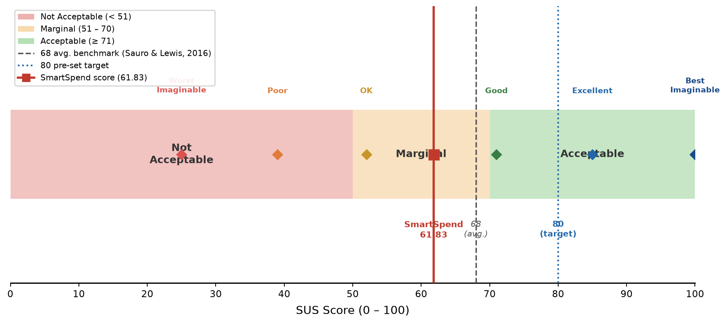
Figure 3: System Usability Scale (SUS) Score Interpretation
Figure 3 shows the SUS Score Interpretation Framework used to evaluate the usability of SmartSpend. SUS scores range from 0 to 100 and were categorized into acceptability levels: Not Acceptable (below 51), Marginal (51 to 70), and Acceptable (71 and above) based on Bangor et al. (2008). Adjective anchors from Bangor et al. (2009) placed 'OK' at approximately 51, 'Good' at 71, and 'Excellent' at 85. The dashed line marks the 68-point average benchmark (Sauro & Lewis, 2016) and the dotted line marks the pre-established target of 80. SmartSpend's mean score of 61.83 is marked with a red line, falling in the Marginal range.
Software Methodology
The development of the SmartSpend mobile application followed the Agile Kanban Software Development Methodology as seen in Figure 4. This approach was selected because the project required continuous feature integration, testing, and refinement, especially due to the involvement of multiple components such as artificial intelligence, OCR processing, and cloud synchronization. Unlike traditional development models that followed a strict and linear sequence, Kanban allowed the researchers to work on tasks dynamically, with phases potentially overlapping or repeating as needed, while continuously improving the system based on feedback and testing results.
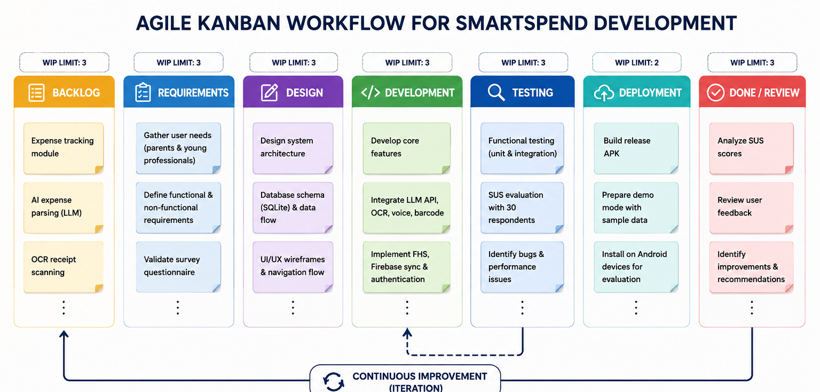
Figure 4: Agile Kanban Workflow for SmartSpend Development
To implement this methodology, the researchers utilized a Kanban board that visually represented the workflow of the project. The board was divided into several columns, namely: Backlog, Requirements, Design, Development, Testing, Deployment, and Done/Review. Each task related to the system such as implementing OCR, integrating the LLM API, or designing the database schema were represented as individual task cards. These cards moved across the board depending on their current progress. Work-in-progress (WIP) limits were also applied to ensure that the researchers focused only on a manageable number of tasks at a time, preventing overload and maintaining productivity.
In the Backlog Phase, all planned features and system requirements were first listed and organized. This included core functionalities such as expense tracking, AI-powered parsing, Financial Health Score computation, voice input integration, receipt scanning, and cloud synchronization. The researchers also included minor features such as theme customization, demo mode, and onboarding tutorials. Each feature was broken down into smaller, actionable tasks to make development more manageable.
During the Requirements Phase, the researchers gathered data through a survey of selected respondents aligned with the study’s target population of parents and young professionals. This phase aimed to identify real-world financial management practices, common challenges in expense tracking, and user expectations for a financial application. Based on the collected data, the researchers defined both functional requirements (e.g., automatic expense logging, AI recommendations) and non-functional requirements (e.g., usability, performance, offline capability).
In the Design Phase, the researchers translated the identified requirements into a concrete system structure. This included designing the application architecture, database schema, and data flow. Specifically, the SQLite database structure was mapped to handle tables such as expenses, income, budgets, savings goals, and chat history. The researchers also designed how data flowed between the mobile application, the LLM API, and Firebase services. Additionally, interface layouts and user navigation flows were planned to ensure that the application remained simple and user-friendly despite having advanced features.
The Development Phase involved the actual implementation of the system using the Flutter framework. The researchers developed the application incrementally by focusing on one feature at a time. For example, the basic expense tracking module was developed first, followed by the integration of AI parsing through the LLM API. After that, additional features such as OCR using Google ML Kit, barcode scanning, and voice input were implemented. Firebase services, including Firestore and Authentication, were also integrated during this phase to support cloud synchronization and secure login. Each completed feature was tested individually before being merged into the main application.
In the Testing Phase, the researchers conducted both functional and usability testing. Functional testing ensured that each feature operated correctly, such as verifying if the OCR accurately extracted receipt data or if the AI correctly categorized expenses. Usability testing involved selected respondents who used the application and evaluated their experience using the System Usability Scale (SUS). The researchers also observed user interactions to identify difficulties, confusion, or inefficiencies within the system. Any issues discovered during this phase were documented and fed back into the Development phase for refinement and correction.
During the Deployment Phase, the completed SmartSpend application was deployed to Android devices for actual usage and evaluation. The researchers prepared the application for demonstration and evaluation by ensuring that all features were stable and properly integrated. Demo Mode was also activated to allow users to explore the system without requiring account registration, making it easier to conduct presentations and usability testing.
Finally, in the Done/Review Phase, the researchers evaluated the overall performance and effectiveness of the system. This included analyzing SUS scores, reviewing user feedback, and assessing whether the application met its intended objectives. Insights gathered from this phase were used to refine the system and document recommendations for future development.
The phases of the Kanban workflow, together with their key tasks and deliverables, were summarized in Table 4.
Table 4: Agile Kanban Workflow Phases and Deliverables
Phase | Key Tasks | Deliverable
Backlog | Define features; needs survey; literature review on PH financial gaps | Prioritized feature list; literature review
Requirements | Translate findings into specs; validate questionnaire; LLM API benchmarking | Validated questionnaire; LLM benchmarking matrix (Table 7)
Design | SQLite schema (26 tables); FHS formula; UI wireframes; data flow diagrams | System architecture; FHS documentation
Development | Build expense tracking; integrate Gemini 3.5 Flash-Lite; add OCR/voice/batch screenshots; FHS engine; Firebase sync; gamification | Functional app; all 34 agentic actions operational
Testing | LLM parsing accuracy; SUS with 30 respondents; survey feedback; bug log | SUS scores; parsing observations; bug documentation
Deployment | Build release APKs; prepare Demo Mode; publish GitHub Releases | Release APKs v3.1.0; project documentation
Done/Review | Analyze SUS scores; review feedback; document recommendations | Final evaluation report; post-capstone roadmap
CHAPTER III
RESULTS AND DISCUSSION
This chapter presented the results of the study in relation to the three objectives stated in Chapter I. It reported the findings of the survey on the financial management practices of parents and young professionals, the comparative evaluation of large language model (LLM) APIs, the computation of the Financial Health Score, the development and features of the SmartSpend mobile application, and the results of the usability and performance evaluation using the System Usability Scale (SUS). Each section ended by stating whether the corresponding objective was achieved.
Assessment of the Financial Management Practices, Budgeting Challenges, and Expense Tracking Behaviors of Parents and Young Professionals
The first objective was to assess the existing financial management practices, common budgeting challenges, and expense tracking behaviors of parents aged 35 to 55 and young professionals aged 21 to 35 in San Fernando City, La Union. Data were gathered through a structured online questionnaire (Financial Management Practices survey) completed by respondents from the target groups.
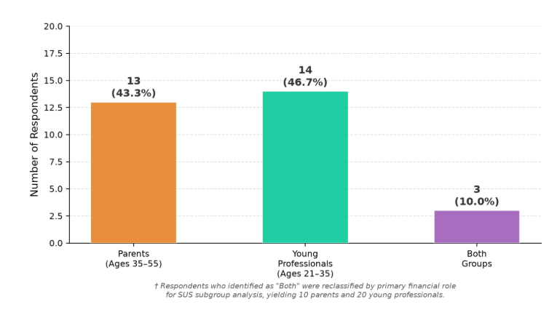
Figure 5: Demographic Distribution of Needs-Assessment Respondents
Figure 5 and Table 6 presented the demographic profile of the 30 respondents and the expense tracking methods they reported. The sample comprised 13 parents aged 35–55 (43.3%), 14 young professionals aged 21–35 (46.7%), and 3 respondents identifying as both (10.0%). In terms of employment, 10 were employed full-time (33.3%), 9 were freelance or contractual (30.0%), 8 were self-employed (26.7%), and 3 were unemployed or part-time (10.0%). GCash was used by 93.3% of respondents (28/30), confirming the relevance of e-wallet transaction import as a core feature.
Table 6: Demographic Profile and Expense Tracking Methods of Respondents (N = 30)
Item | Parents (n = 13) | Young Professionals (n = 14) | Both (n = 3)† | Total (N = 30)†
A. Demographic profile, f (%)
Parents aged 35–55 | 13 (43.3%)
Young professionals aged 21–35 | 14 (46.7%)
Both groups | 3 (10.0%)
Employed full-time | 10 (33.3%)
Freelance or contractual | 9 (30.0%)
Self-employed | 8 (26.7%)
Unemployed or part-time | 3 (10.0%)
GCash users | 28 (93.3%)
B. Expense tracking methods used, f (%)
Receipts | 11 (84.6%) | 13 (92.9%) | 3 (100.0%) | 27 (90.0%)
Mental estimates | 8 (61.5%) | 7 (50.0%) | 1 (33.3%) | 16 (53.3%)
E-wallet transaction history | 6 (46.2%) | 6 (42.9%) | 1 (33.3%) | 13 (43.3%)
Notes app | 4 (30.8%) | 5 (35.7%) | 0 (0.0%) | 9 (30.0%)
Notebook | 3 (23.1%) | 3 (21.4%) | 1 (33.3%) | 7 (23.3%)
Mobile app | 1 (7.7%) | 2 (14.3%) | 0 (0.0%) | 3 (10.0%)
Note. Respondents could select more than one tracking method, so percentages were computed within each group (parents n = 13, young professionals n = 14, both n = 3) and for the total sample (N = 30); columns therefore did not sum to 100%.
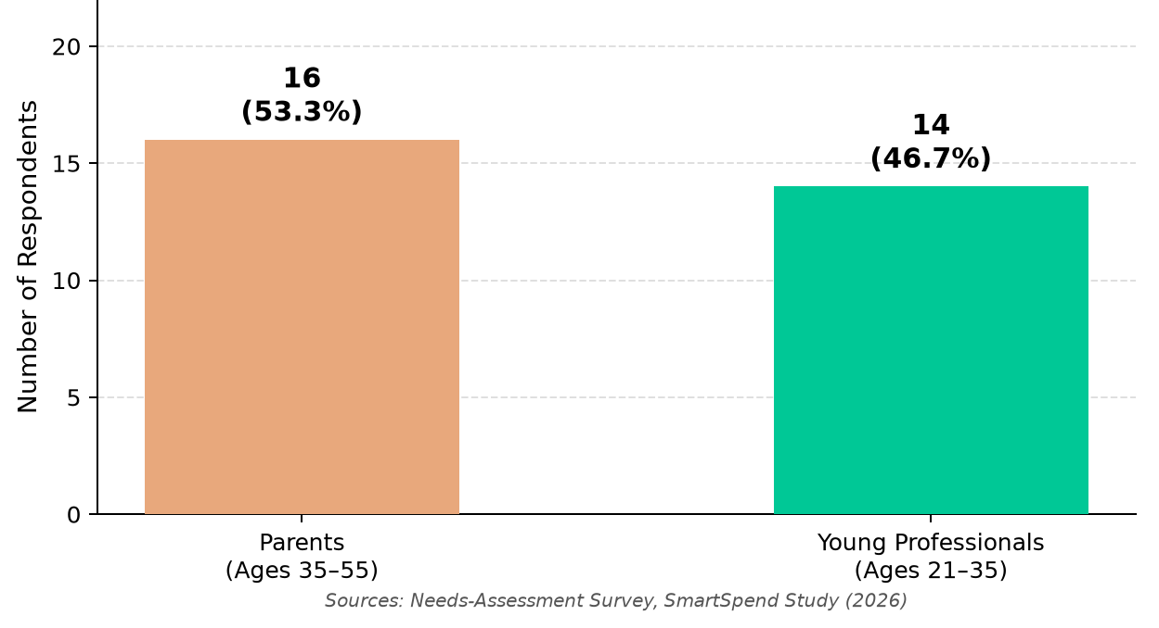
Figure 6: Demographic Distribution of Needs-Assessment Respondents (N = 30).
Figure 6 presents the demographic distribution of the 30 needs-assessment respondents, showing the proportion of parents, young professionals, and those belonging to both groups.
The 3 respondents who identified as both parent and young professional were reclassified by primary financial role for SUS subgroup analysis, yielding 10 parents and 20 young professionals. Receipts were the most common way of tracking expenses (27 of 30, 90.0%), followed by mental estimates (16 of 30, 53.3%) and e-wallet transaction history (13 of 30, 43.3%). Notes apps (30.0%) and paper notebooks (23.3%) were less common, and only 3 respondents (10.0%) used a dedicated mobile app. Most respondents therefore relied on manual or memory-based tracking, which supported the case for automated capture through receipt scanning and e-wallet screenshot import.
The findings confirmed the critical financial management challenges identified in the literature. Among the 30 respondents, 96.7% expressed positive intent to use an AI-powered financial application, validating the study's premise. The most prevalent challenges were rising prices of basic goods, unexpected medical expenses, and family responsibilities. GCash was used by 93.3% of respondents, validating the app's emphasis on e-wallet transaction parsing.
These results showed that the first objective of the study was achieved: the financial management practices, budgeting challenges, and expense tracking behaviors of the target population were successfully assessed through the validated survey instrument.
Design and Development of the SmartSpend Mobile Application
The second objective was to design and develop the SmartSpend mobile application, including the selection of an appropriate Large Language Model API through comparative technical evaluation.
- SmartSpend was developed as an Android mobile application using Flutter for the UI, SQLite for local storage, Firebase for cloud sync, and a large language model API for AI-powered expense parsing and financial assistance.
The selection of an appropriate LLM API was a critical design decision because it directly influenced the accuracy, latency, and cost of natural language expense parsing and conversational assistance. For a mobile financial assistant requiring Filipino-English capability and free-tier deployment, the evaluation criteria were weighted as: Filipino-English accuracy (25%), speed/latency (20%), tool use and JSON reliability (20%), free tier availability (15%), context window (10%), and financial reasoning quality (10%). Table 7 presented the comparative evaluation results.
Table 7: Comparative Evaluation of LLM APIs for SmartSpend Integration
Model | Provider | Context | Speed (t/s) | Filipino | Tool Use | Free Tier
Gemini 3.5 Flash-Lite | Google | 1,048,576 | ~400–600 | 5/5 | 5/5 | ~500/day
Gemini 3.5 Flash | Google | 1,048,576 | ~200–400 | 5/5 | 5/5 | ~20/day
GPT-OSS 120B | Groq LPU | 131,072 | ~500 | Not measured | 5/5 | ~1,000/day
Qwen 3.6 27B | Groq LPU | 131,072 | Not measured | Not measured | 5/5 | 1,000/day
Qwen 3.8 27B | Groq LPU | 131,072 | Not measured | Not measured | 5/5 | 1,000/day
GPT-OSS 20B | Groq LPU | 131,072 | Not measured | Not measured | 5/5 | 1,000/day, 30K TPM
Groq Compound Mini | Groq LPU | 131,072 | Not measured | Not measured | 5/5 (web+code) | 1,000/day
GPT-OSS 120B | Cerebras WSE | 131,072 | ~3,000 | Not measured | 5/5 | 1M tokens/day
Gemini 3.5 Flash-Lite was selected as the primary model based on its high free-tier request quota, strong Filipino-English (Taglish) handling, 1-million token context window, and native function calling support for the 34 agentic action types. Seven fallback providers ensured continued availability if the primary model was unavailable.
SmartSpend used dynamic full-context injection rather than RAG. A typical user had 20–50 expenses, 5–10 budgets, and 3–5 goals (~1,000–5,000 tokens), fitting within any evaluated model's context window. RAG added unnecessary vector search overhead for this small per-user dataset (Davenport & Mittal, 2022).
The Financial Health Score (FHS) was SmartSpend's core academic contribution formally positioned as a Prototype Observed Financial Health Indicator (FHI), adapting ideas from two published financial-health measurement efforts rather than inventing a scoring system from nothing. The main design choice computing the score from a user's own transaction data instead of a survey followed the Commonwealth Bank of Australia and Melbourne Institute's (CBA-MI) "Observed" scale, which summed categorical bank-record measures and rescaled the total to 0–100 (Comerton-Forde et al., 2018). Three of the four components below adapted the Spend, Save and Plan ideas from the Financial Health Network's FinHealth Score® (Financial Health Network, 2021). The UNSGSA's own working-group note on measuring financial health treated transaction/account-based measurement as a promising but still early-stage fourth approach, better viewed as complementary to survey-based scales rather than a full replacement (Gubbins, Mazzotta & Rhyne, 2021) which was exactly why this score was named a "Prototype," not presented as a validated instrument in its own right.
Equal weights that added up to 100 followed the simplest published scoring method for this kind of scale. CBA's own 10-question Reported scale gave each question equal weight (0–4 points, 40 total) and multiplied by 2.5 to land on a 0–100 range, and separate validation testing found that this simple approach correlated very highly with more complex model-based scores (Gubbins, Mazzotta & Rhyne, 2021). SmartSpend followed the same logic with four components: 4 × 25 = 100. The weights themselves were a design choice, not a statistically derived result that was stated plainly rather than implied to be more rigorous than it was.
Full Mode (income tracking enabled; 4 components of 25 points, 100 maximum):
1. Savings Rate (25 pts): Score = 25 × min(1.0, savingsRate / 0.20). The 20% target came from the 50/30/20 budgeting rule (Warren & Tyagi, 2005).
2. Overspend Control (25 pts): Score = 25 × (1 − (hardOverDays + softOverDays × 0.5) / activeDays). A day where a single large one-off purchase (e.g., a gadget or event ticket) pushes spending over the daily budget counts as a "soft" overspend day at half weight; a day with scattered, habitual overspending across multiple items counts as "hard" at full weight.
3. Budget Adherence (25 pts): Score = 25 × (onBudgetCategories / totalBudgetedCategories). Category-level budget limits tracked whether the user stayed within each spending category for the period.
4. Logging Consistency (25 pts): Score = 25 × (loggedDays / activeDays). Consistent self-monitoring increased transaction salience and promoted deliberate spending (Thaler & Sunstein, 2008).
Detailed formula specifications for Lightweight Mode (designed for students, freelancers, and informal workers without income tracking) and score adjustments are available in the application documentation.
System Development Results
Overview of the System

Figure 7. SmartSpend System Flowchart
Figure 7 presents the system flowchart of SmartSpend, illustrating how user inputs are processed through on-device redaction, routed to either a local or cloud LLM provider, parsed into agentic actions, and stored in the SQLite database with optional Firestore synchronization.

Figure 8. Use Case Diagram
Figure 8 shows the use case diagram of SmartSpend. The user can log expenses, import screenshots, chat with the AI assistant (Peso), set budgets and savings goals, view analytics, and check the Financial Health Score. The system handles FHS calculation, notifications, and cloud synchronization.


Figure 9. Visual Table of Contents
Figure 9 presents the visual table of contents of SmartSpend, showing the navigation structure from the login screen to the home dashboard and its connected modules including Expenses, Budget, Savings, Analytics, AI Chat, Achievements, and Settings.
Several Filipino-specific and usability features were implemented over the course of development rather than left as future work: a Paluwagan (rotating savings group) tracker built on the existing debt and recurring-transaction infrastructure; a six-month savings-rate trend chart with a 20% target line in Analytics; a long-press quick-edit gesture on budget tiles; and an offline cache fallback for the AI-generated financial advice and monthly summary cards, so a quota error did not leave the user without any insight.
Two further additions were worth documenting as part of the system's development: first, a full audit-trail subsystem (four dedicated history tables wallet, budget, goal-contribution, and income each logging the old value, new value, change amount, reason, and source of every edit, viewable per-item via a long-press) gave the app's financial records the kind of change-of-custody traceability expected of a financial tool, not just a flat transaction log. Second, the AI assistant's system prompt was extended with structured knowledge of common Philippine Buy-Now-Pay-Later and short-term lending products (GLoan, Maya Loan, ShopeePayLater, LazPayLater, HomeCredit, BillEase, Skyro, Akulaku, Atome, UnaCash), including their typical monthly interest rates and the Bangko Sentral ng Pilipinas' interest rate cap under BSP Circular No. 1133, so that the assistant could meaningfully discuss a user's installment and lending obligations rather than treating them as generic expenses.
Development was iterative across multiple versions from v2.9.9 to v3.1.0, with progressive feature additions culminating in the final evaluated version SmartSpend v3.1.0.
SmartSpend handled AI privacy through two active tiers. In Cloud AI mode, requests passed through the provider chain with mobile numbers, reference numbers, and bank-account patterns redacted on-device before transmission, reducing but not eliminating exposure. In Private Local Mode, requests went only to a model running on the user's own network, with financial data not leaving the local network. A one-time privacy disclosure was shown before the first AI message.
From v3.0.5 to v3.1.0, the app's mascot Peso evolved from a static icon into a context-aware animated companion with 12 moods that changed based on the Financial Health Score tier and AI reply sentiment. Peso delivered short Taglish messages across 31 situations and provided once-per-session contextual tips on 17 screens, reinforcing engagement and financial habit formation.
The optional local AI integration shipped with a guided in-app setup flow covering three common local-inference tools: Ollama, LM Studio, and Jan, including a hardware-tier picker to help users choose an appropriate model size for their device.

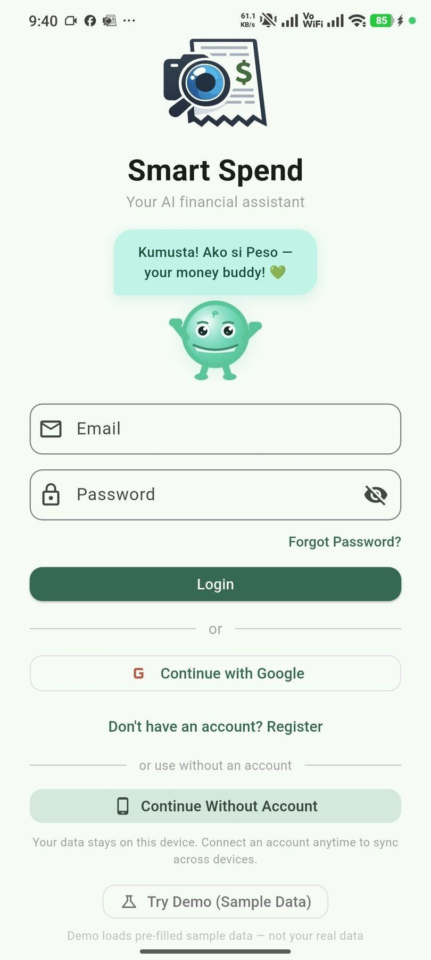
Figure 10. Login and Demo Mode Screen
Figure 10 presents the Login and Demo Mode Screen of SmartSpend. Users can sign in with an account, continue without an account for local-only storage, or try Demo Mode which loads realistic sample data for exploration without registration.
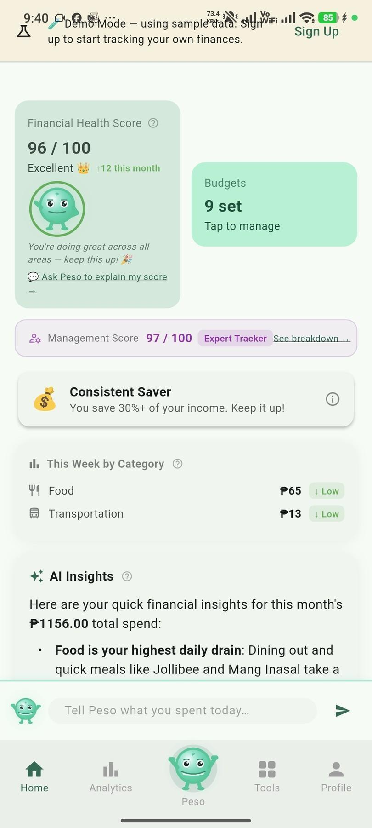

Figure 11. Home Dashboard
Figure 11 presents the Home Dashboard of SmartSpend, which displays the user's Financial Health Score, recent transactions, and spending insights. The dashboard served as the main navigation screen for accessing all key features of the application.

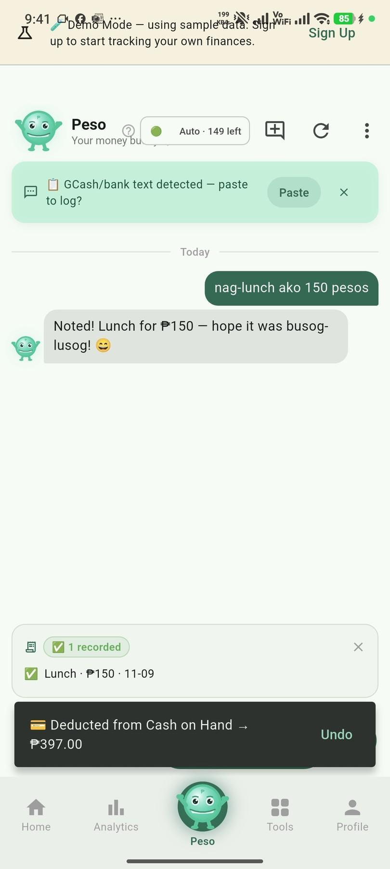
Figure 12. Expense Logging Through Peso Chat
Figure 12 presents the Peso Chat interface, where users logged expenses through natural language input in Filipino, English, or Taglish. The AI assistant parsed the input and automatically recorded the transaction with the appropriate category and amount.
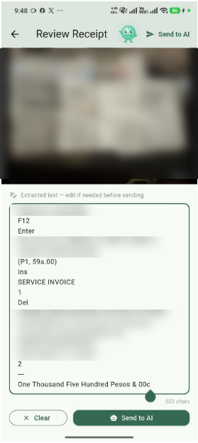
Figure 13. Receipt Scanning and Batch Screenshot Import
Figure 13 shows the receipt scanning and batch screenshot import feature. The app used OCR to extract transaction details from physical receipts and e-wallet screenshots. Users could review, edit categories, and confirm entries before recording them.
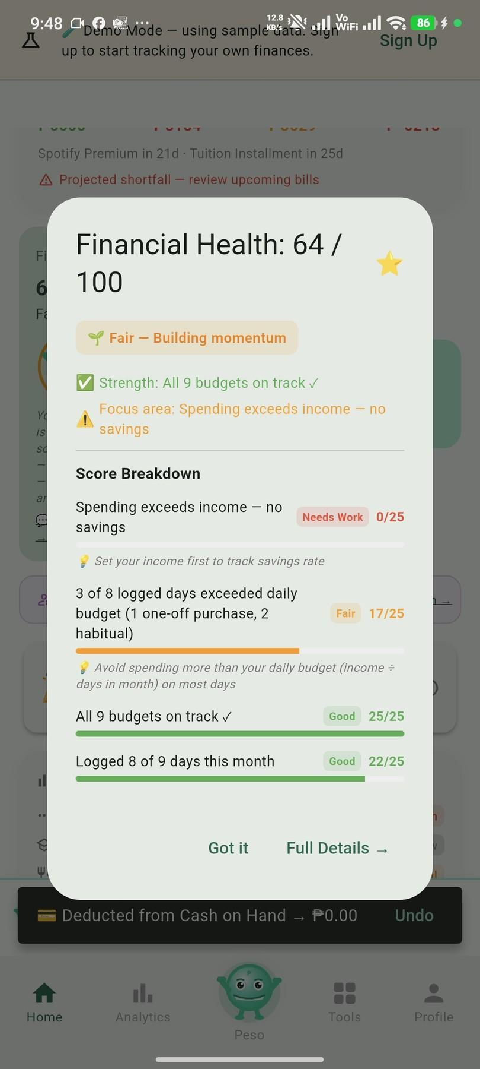
Figure 14. Financial Health Score Breakdown
Figure 14 displays the Financial Health Score breakdown screen, showing the user's scores for each component: Savings Rate, Overspend Control, Budget Adherence, and Logging Consistency. The overall score out of 100 provides a quick summary of the user's budgeting behavior.
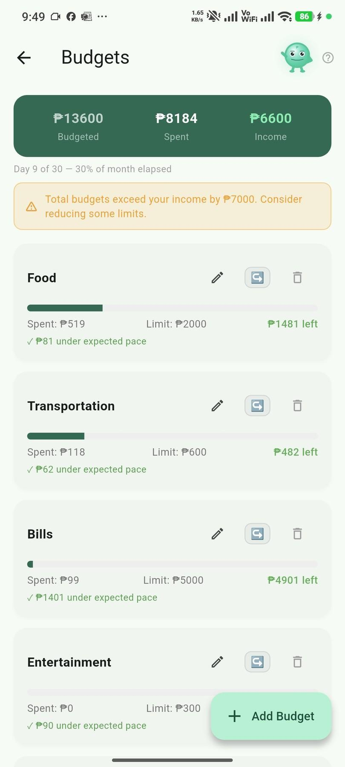
Figure 15. Budgets, Safe-to-Spend, and Savings Goals
Figure 15 shows the Budgets, Safe-to-Spend, and Savings Goals screen. Users set spending limits per category and monitored their adherence. The screen also displays the calculated safe-to-spend amount and progress toward savings goals.
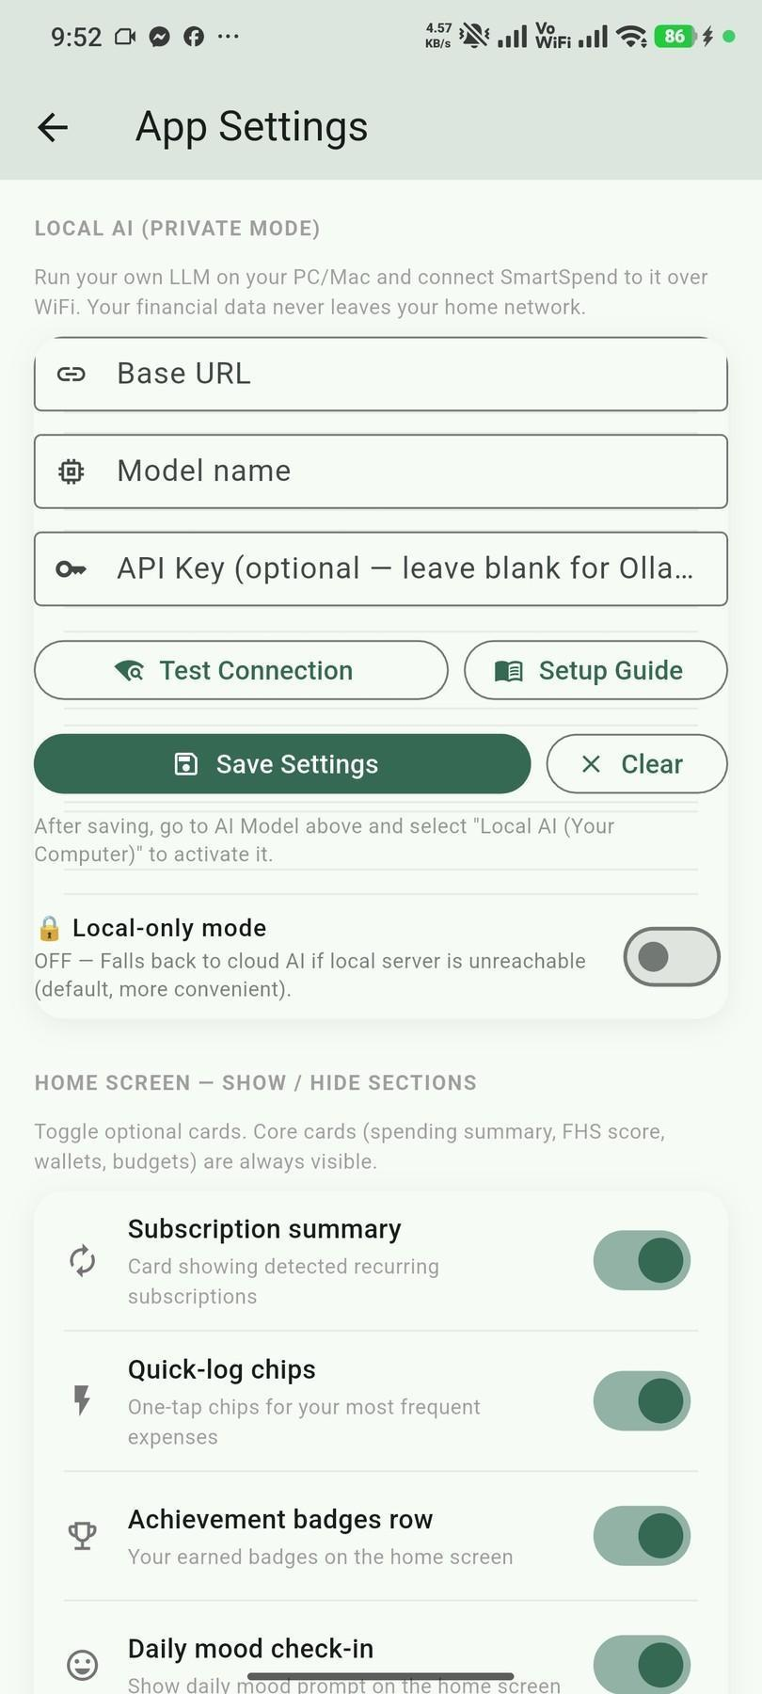
Figure 16. Local AI Mode Setup
Figure 16 presents the Local AI Mode setup screen. This screen guides users in configuring an optional offline AI model on their home network for use without sending data to external providers. The setup flow includes hardware guidance to help users choose an appropriate model for their device.
These results showed that the second objective of the study was achieved: SmartSpend v3.1.0 was designed and developed as a working Android application, and a suitable LLM API was selected through a comparative technical evaluation.
Determined the Usability of SmartSpend Using the System Usability Scale
Respondents were required to use the SmartSpend application either the full version or the built-in Demo Mode accessible from the login screen for a minimum of 10 minutes before completing the SUS questionnaire. This was enforced through a screening question at the start of the SUS form. Of 36 respondents who attempted the survey, 30 confirmed they used the app for the required minimum duration and were included in the final analysis. The remaining 6 were excluded: 5 for insufficient app usage time and 1 for straight-line response bias. The respondents for the needs assessment (Objective 1) and for the SUS evaluation (Objective 3) were separate groups; some individuals may have taken part in both, but the two samples were analyzed independently for their respective objectives.
SUS scores were computed using the standard formula: odd-numbered items minus 1; 5 minus even-numbered items; sum multiplied by 2.5 (Brooke, 1996). The overall SUS score was interpreted against the Bangor, Kortum, and Miller (2009) adjective rating scale.

Figure 17. SUS Computation Table
Figure 17 presents a sample SUS computation for one respondent who scored 75.0, illustrating how the SUS formula is applied. For odd-numbered items, the contribution is the scale position minus 1; for even-numbered items, it is 5 minus the scale position. The sum is multiplied by 2.5. This is a single example; the overall mean of 61.83 shown in Table 8 is the average across all 30 respondents.
Table 8. Overall SUS Result
Overall SUS Score | Grade | Adjective | Acceptable
61.83 | D | OK | No (below the 68 benchmark and the 80 target)
As shown in Table 8, SmartSpend obtained an overall SUS score of 61.83, a grade of D, and an adjective rating of "OK" (Bangor et al., 2009), which was below the pre-established acceptance threshold of 80 or above and below the 68-point average benchmark (Sauro & Lewis, 2016).
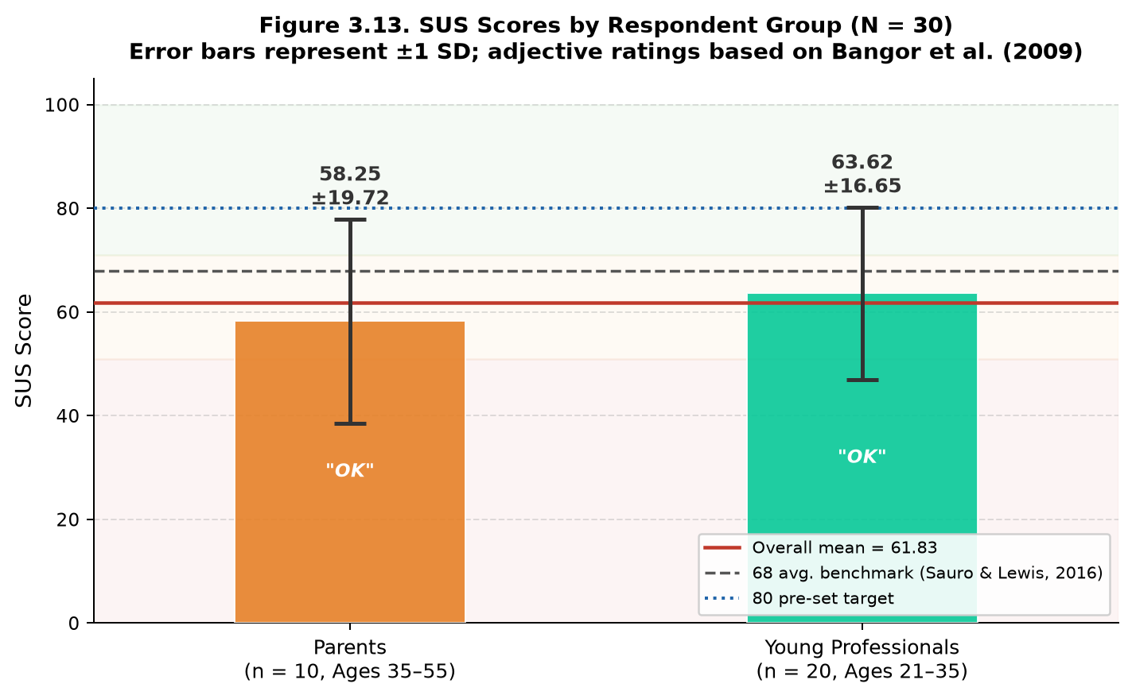
Table 9. System Usability Scale (SUS) Results by Respondent Group

Respondent Group | N | Mean SUS Score | SD | Range | Adjective Rating
Parents (35–55) | 10 | 58.25 | 19.72 | 35.0–90.0 | OK
Young Professionals (21–35) | 20 | 63.62 | 16.65 | 42.5–92.5 | OK
Combined | 30 | 61.83 | 17.58 | 35.0–92.5 | OK
As shown in Tables 8 and 9, SmartSpend achieved an overall mean SUS score of 61.83 (SD = 17.58; median = 55.00; range = 35.0–92.5) with an adjective rating of "OK" per Bangor et al. (2009). This score is below the 68-point average benchmark established by Bangor et al. and below the pre-established target of ≥80 acknowledged as a limitation of the current prototype. Young professionals (n = 20, M = 63.62, SD = 16.65) scored slightly higher than parents (n = 10, M = 58.25, SD = 19.72), and both groups fell within the “OK” range. Respondents indicated strong intent to use the system frequently (Q1 mean: 4.35/5) and felt confident using it (Q9 mean: 4.19/5). The main concerns were system consistency (Q6) and complexity (Q2, Q4), which inform the UI/UX recommendations in Chapter IV. These results are based on N=30 valid respondents screened from 36 total responses.
No formal open-ended survey data was collected. The study used a structured quantitative survey instrument, and no open-ended or interview data were collected.
These results showed that the third objective of the study was partially achieved: usability was evaluated using the System Usability Scale with 30 valid respondents, but the mean score of 61.83 fell below the 68-point benchmark (Sauro & Lewis, 2016) and the pre-established target of 80.
CHAPTER IV
CONCLUSIONS AND RECOMMENDATIONS
This chapter presented the conclusions drawn from the results of the study and the recommendations of the researchers.
Conclusions
The needs assessment confirmed that 96.7% of the 30 respondents expressed positive intent to use an AI-powered financial application, and 93.3% already use GCash validating the study's target population and feature priorities. SmartSpend v3.1.0 was successfully developed with all identified features implemented. The SUS evaluation yielded a mean score of 61.83 (adjective: "OK"), below the ≥80 target but acceptable for a prototype system. Therefore, all three objectives of the study were addressed, with the third objective partially achieved pending UI refinements in future iterations.
SmartSpend v3.1.0 was developed as a working Android application with multi-modal expense input, offline-first local storage, 34 AI actions, and a Financial Health Score formally classified as a Prototype Observed Financial Health Indicator. The comparative evaluation of 20 candidate LLM models led to the selection of Gemini 3.5 Flash-Lite as the primary model, supported by a multi-provider failover chain. Therefore, the second objective of designing and developing the SmartSpend mobile application, including the selection of a suitable LLM API, was achieved.
SmartSpend obtained an overall mean SUS score of 61.83 (SD = 17.58) from 30 screened respondents. Per Bangor, Kortum, and Miller (2009), this corresponded to an adjective rating of 'OK' (Grade D), below the 68-point average benchmark and the pre-established target of ≥80. The third objective was partially achieved.
Recommendations
In view of the results of the study, the following recommendations were made:
1. Payday-cycle-aware budgeting. The researchers recommended that the developers implement budgeting resets aligned with the semi-monthly (15th and 30th) salary cycle common in the Philippines.
2. Backend API proxy and per-user keys. The researchers recommended that the developers move LLM API key management to a server-side proxy (e.g., Firebase Cloud Function) to remove device-side key exposure and enforce per-user message limits, because the free-tier request quotas (Table 7) were shared by every user of the prototype. Letting users add their own key was an interim measure.
3. Google Play release. The researchers recommended that, after the backend proxy and a privacy policy were in place, the developers submit SmartSpend to the Google Play Store, since the prototype was currently distributed as a downloadable APK.
4. On-device AI tier. The researchers recommended that the developers add an opt-in on-device model (e.g., Gemma 4 E2B through Google's LiteRT-LM, about a 2.6 GB download) for users who wanted fully offline AI, routing only simple logging tasks to it and keeping complex financial advice on the cloud tier, because the current local AI mode required a separate computer on the same network.
5. SQLite encryption. The researchers recommended that the developers implement SQLCipher-based encryption for the local database in a future schema migration, because the local database of the prototype was not encrypted.
6. Household and remittance features. The researchers recommended that the developers add shared couple and family wallets and inbound OFW remittance tracking as a distinct income category to serve more user groups.
7. Longitudinal evaluation. The researchers recommended that future researchers measure SmartSpend's effect on financial behavior over three to six months with a larger sample, because the usability evaluation in this study measured usability at a single point in time.
8. UI/UX refinement. The researchers recommended that the developers address the main usability concerns identified in the SUS results — particularly system consistency (Q6) and complexity (Q2) — through interface redesign in a future iteration to improve the overall usability score.
9. Formal parsing evaluation. The researchers recommended that future researchers conduct a formal evaluation of the OCR and AI parsing accuracy using standardized test receipts across multiple platforms to establish a reliable performance baseline for the multimodal import features.

References
Agila: Finance Coach. (2026). Agila: Finance Coach [Mobile app]. Google Play / App Store.
Ariely, D. (2008). Predictably irrational: The hidden forces that shape our decisions. HarperCollins.
Bangko Sentral ng Pilipinas. (2021). 2021 Financial Inclusion Survey. https://www.bsp.gov.ph/Inclusive-Finance/Financial-Inclusion-Surveys/2021-FIS-Report.pdf
Bangko Sentral ng Pilipinas. (2025). Consumer Finance and Inclusion Survey (CFIS) 2025.
Bangor, A., Kortum, P. T., & Miller, J. T. (2008). An empirical evaluation of the System Usability Scale. International Journal of Human–Computer Interaction, 24(6), 574–594.
Bangor, A., Kortum, P., & Miller, J. (2009). Determining what individual SUS scores mean: Adding an adjective rating scale. Journal of Usability Studies, 4(3), 114–123.
Bitrián, P., Buil, I., & Catalán, S. (2021). Making finance fun: The gamification of personal financial management apps. International Journal of Bank Marketing, 39(7), 1310–1332. https://doi.org/10.1108/IJBM-02-2021-0074
Bociek, J. (2023). mobile_scanner: A universal barcode and QR code scanner for Flutter [Computer software]. https://pub.dev/packages/mobile_scanner
Brooke, J. (1996). SUS: A “quick and dirty” usability scale. In P. W. Jordan, B. Thomas, B. A. Weerdmeester, & I. L. McClelland (Eds.), Usability evaluation in industry (pp. 189–194). Taylor & Francis.
BunnyWise. (2026). BunnyWise: All-in-one investment tracker [Mobile app]. https://bunnywise.io
Comerton-Forde, C., Ip, E., Ribar, D. C., Ross, J., Salamanca, N., & Tsiaplias, S. (2018). Using survey and banking data to measure financial wellbeing (Financial Wellbeing Scales Technical Report No. 1). Commonwealth Bank of Australia & Melbourne Institute.
Creswell, J. W., & Plano Clark, V. L. (2011). Designing and conducting mixed methods research. Sage Publications.
Davenport, T. H., & Mittal, N. (2022). All-in on AI: How smart companies win big with artificial intelligence. Harvard Business Review Press.
Davis, F. D. (1989). Perceived usefulness, perceived ease of use, and user acceptance of information technology. MIS Quarterly, 13(3), 319–340.
Deci, E. L., & Ryan, R. M. (2000). The “what” and “why” of goal pursuits: Human needs and the self-determination of behavior. Psychological Inquiry, 11(4), 227–268.
Duhigg, C. (2012). The power of habit: Why we do what we do in life and business. Random House.
Dwivedi, Y. K., Hughes, L., Ismagilova, E., Aarts, G., Coombs, C., Crick, T., Duan, Y., Dwivedi, R., Edwards, J., Eirug, A., Galanos, V., Ilavarasan, P. V., Janssen, M., Jones, P., Kar, A. K., Kizgin, H., Kronemann, B., Lal, B., Lucini, B., … Williams, M. D. (2021). Artificial intelligence (AI): Multidisciplinary perspectives on emerging challenges, opportunities, and agenda for research, practice and policy. International Journal of Information Management, 57, Article 101994. https://doi.org/10.1016/j.ijinfomgt.2019.08.002
Financial Health Network. (2021). FinHealth Score® toolkit and methodology. https://finhealthnetwork.org
Flores, C. A. R. (2025). Financial freedom of Filipinos in personal finance management. Pantao: The International Journal of the Humanities and Social Sciences, 4(1). https://pantaojournal.com/2025/01/27/v4-i1-7/
Flutter 4 Fun. (2022). fl_chart: A highly customizable Flutter chart library [Computer software]. https://pub.dev/packages/fl_chart
GCash/Mynt. (2026). GCash launches the country’s first AI financial coach.
Google. (2024a). Firebase authentication documentation. https://firebase.google.com/docs/auth
Google. (2024b). Firebase Crashlytics documentation. https://firebase.google.com/docs/crashlytics
Google. (2024c). Firebase Firestore documentation. https://firebase.google.com/docs/firestore
Google. (2024d). Flutter documentation. https://flutter.dev/docs
Google. (2024e). Google ML Kit documentation. https://developers.google.com/ml-kit
Groq. (2026). Groq API documentation and model deprecations.
Hean, O., Saha, U., & Saha, B. (2025). Can AI help with your personal finances? Applied Economics. https://doi.org/10.1080/00036846.2025.2450384
Inquiro. (2024). Financial literacy in the Philippines: Key statistics. Inquiro Analytics. https://inquiro.ph/financial-literacy-in-the-philippines-2024-key-statistics/
Kahneman, D., & Tversky, A. (1979). Prospect theory: An analysis of decision under risk. Econometrica, 47(2), 263–292.
Kibo. (2026). Kibo: AI expense tracker [Mobile app]. Google Play.
Li, Z., et al. (2024). A survey of large language models for financial applications. arXiv. https://arxiv.org/abs/2406.11903
Lista. (2026). Lista: Personal & business finance tracker [Mobile app]. Google Play.
National Privacy Commission. (2012). Republic Act No. 10173: Data Privacy Act of 2012. Republic of the Philippines. https://privacy.gov.ph/data-privacy-act/
OpenAI. (2023). GPT-4 system card. https://openai.com/research/gpt-4-system-card
Philippine Statistics Authority. (2021). Family Income and Expenditure Survey (FIES) 2021. https://www.psa.gov.ph
PISO Budget Tracker. (2026). PISO Budget Tracker [Mobile app]. Google Play.
Ramsey, D. (2003). Financial peace revisited. Viking.
Roux, A. (2019). sqflite: SQLite plugin for Flutter [Computer software]. https://pub.dev/packages/sqflite
Sauro, J., & Lewis, J. R. (2016). Quantifying the user experience: Practical statistics for user research (2nd ed.). Morgan Kaufmann.
Sloane, L. (2022). speech_to_text: A Flutter plugin for on-device speech recognition [Computer software]. https://pub.dev/packages/speech_to_text
Statista. (2024). Number of mobile app downloads worldwide. https://www.statista.com/statistics/271644/worldwide-free-and-paid-mobile-app-store-downloads/
Stefanov, T., Stefanova, M., & Varbanova, S. (2024). Personal finance management application. TEM Journal, 13(3), 2066–2075. https://doi.org/10.18421/TEM133-34
Tarsi – Budget Tracker. (2026). Tarsi – Budget Tracker [Mobile app]. App Store. https://apps.apple.com/ph/app/tarsi-budget-tracker/
Thaler, R. H., & Sunstein, C. R. (2008). Nudge: Improving decisions about health, wealth, and happiness. Yale University Press.
The Flutter Authors. (2013). local_auth: Flutter plugin for biometric authentication [Computer software]. https://pub.dev/packages/local_auth
UNSGSA. (2021). Measuring financial health: Concepts and considerations. https://www.unsgsa.org
Warren, E., & Tyagi, A. W. (2005). All your worth: The ultimate lifetime money plan. Free Press.
World Bank. (2022). Global Findex Database 2021. https://www.worldbank.org/en/publication/globalfindex
Yomio. (2026). YNAB alternatives: Which budget app actually works in 2026? https://yomio.app/en/blog/ynab-alternatives
ZXing Project. (2023). ZXing barcode scanning library [Computer software]. https://github.com/zxing/zxing

APPENDICES
APPENDIX A
Survey Questionnaire
SmartSpend: An AI-Assisted Mobile Financial Tracking and Advisory Application for Parents and Young Professionals in La Union
Dear Respondent:
Good day! The researchers are conducting a study entitled “SmartSpend: An AI-Assisted Mobile Financial Tracking and Advisory Application for Personal Financial Management.” This questionnaire aims to assess the existing financial management practices, common budgeting challenges, and expense-tracking behaviors of parents and young professionals.
Your participation is voluntary. Please answer the questions honestly by selecting the option or options that best describe your experience. For questions marked “Select all that apply,” you may choose more than one answer. Your responses will be treated confidentially and used for academic purposes only.
Eligibility: This needs-assessment questionnaire is intended for parents aged 35–55 who manage household finances and young professionals aged 21–35 who independently manage their income and expenses.

Section A – Respondent Profile
1. What is your age?
○ 21–25
○ 26–30
○ 31–34
○ 35–40
○ 41–45
○ 46–50
○ 51–55
○ Below 21 / Above 55 (not eligible for this study)
2. Which category best describes you?
○ Parent
○ Young professional
○ Both a parent and a young professional
○ Neither

3. What is your current employment status?
○ Employed full-time
○ Employed part-time
○ Self-employed / business owner
○ Freelance / contractual
○ Government employee
○ Unemployed
○ Other: ____________________
SECTION B. EXISTING FINANCIAL MANAGEMENT PRACTICES
This section gathers information about how respondents currently plan and manage their personal or household finances.
4. Do you prepare a budget for your personal or household finances?
○ Always
○ Often
○ Sometimes
○ Rarely
○ Never
5. Do you set aside money for savings before spending on other expenses?
○ Always
○ Often
○ Sometimes
○ Rarely
○ Never
SECTION C. COMMON BUDGETING CHALLENGES
This section identifies the difficulties respondents experience when managing their finances.
6. What are the main challenges you experience when managing your finances? (Select all that apply.)
☐ Insufficient income
☐ Increasing prices of basic goods and services
☐ Unexpected medical or emergency expenses
☐ Family responsibilities or dependents
☐ Difficulty controlling discretionary spending
☐ Debt or loan repayments
☐ Irregular income
☐ Lack of a clear budget
☐ Difficulty recording expenses
☐ Difficulty tracking several financial obligations
☐ Lack of time to manage finances
☐ Lack of knowledge about budgeting
☐ I do not experience significant budgeting challenges
☐ Other: ____________________
7. What do you usually do when you realize that you have exceeded your budget? (Select all that apply.)
☐ Reduce spending in other categories
☐ Use savings
☐ Delay nonessential purchases
☐ Borrow money
☐ Use credit
☐ Seek additional income
☐ Continue spending without adjusting the budget
☐ Other: ____________________
8. What would help you manage your budget more effectively? (Select all that apply.)
☐ Automatic expense categorization
☐ Budget limits for each category
☐ Notifications when approaching a budget limit
☐ Bill and payment reminders
☐ Savings goal tracking
☐ Monthly financial summaries
☐ Spending trend reports
☐ Debt and loan tracking
☐ Financial education or budgeting tips
☐ Other: ____________________
SECTION D. EXPENSE TRACKING BEHAVIORS
This section asks how respondents record and monitor their expenses.
9. Do you currently record your personal or household expenses?
○ Always
○ Often
○ Sometimes
○ Rarely
○ Never
10. How do you record your expenses? (Select all that apply.)
☐ Notebook or diary
☐ Spreadsheet
☐ Mobile financial management application
☐ Notes application
☐ Receipts
☐ Banking or e-wallet transaction history
☐ Mental estimates or memory
☐ I do not record expenses
☐ Other: ____________________
11. Which expenses do you usually track? (Select all that apply.)
☐ Cash purchases
☐ Debit card transactions
☐ Credit card transactions
☐ Bank transfers
☐ E-wallet transactions
☐ Online purchases
☐ Recurring bills
☐ Loan repayments
☐ Savings contributions
☐ All of the above
☐ None of the above

SECTION E. SUPPLEMENTARY PROFILE AND FEATURE NEEDS
This section gathers information about respondents’ interest in an AI-powered financial assistant and the platforms they would like to track.
12. Would you use an AI-powered financial assistant application to help manage your finances?
○ Yes, definitely
○ Probably yes
○ Not sure
○ Probably not
○ No
13. Which digital wallets or banking platforms do you currently use that you want the AI assistant to help you track? (Select all that apply.)
☐ GCash
☐ Maya (formerly PayMaya)
☐ GoTyme Bank
☐ Traditional online banking (e.g., BDO, BPI, Metrobank)
☐ E-commerce platforms (e.g., Shopee, Lazada)
☐ Others (please specify): ____________________
Thank you for your time and participation.

APPENDIX B
INFORMED CONSENT FORM
SmartSpend: An AI-Assisted Mobile Financial Tracking and Advisory Application for Personal Financial Management
Dear Participant:
You are invited to participate in a research study conducted by Bachelor of Science in Information Technology students of Lorma Colleges. Before deciding whether to participate, please read the information below. You may ask the researchers to clarify anything you do not understand.
Purpose of the Study
The study aims to assess the financial management practices, budgeting challenges, and expense-tracking behaviors of parents and young professionals; design and develop the SmartSpend mobile application; and evaluate the application's usability using the System Usability Scale (SUS) and user feedback.
Who May Participate
The study focuses on parents aged 35–55 who serve as household financial managers and young professionals aged 21–35 who independently manage their income and expenses. Participation in the SUS evaluation is intended for eligible adult participants who have tried the SmartSpend application.
Study Procedures
Depending on the stage of the study, you may be invited to: (1) answer the financial-management survey; and/or (2) try the SmartSpend application through a demonstration or Demo Mode and complete the SUS questionnaire and optional feedback questions. The SUS questionnaire should be completed only after you have had an opportunity to use or explore the application.
Voluntary Participation and Withdrawal
Your participation is voluntary. You may decline to answer any question that you are not comfortable answering and may stop participating at any time without penalty or loss of any benefit to which you are otherwise entitled.
Possible Risks and Benefits
No significant risks are anticipated. Some questions concern personal or household financial practices, and you may skip a question if you do not wish to answer it. You may not receive a direct personal benefit; however, your responses may help the researchers improve the SmartSpend application and contribute to the study.
Confidentiality and Data Handling
The researchers will use the information collected for academic purposes. Survey and evaluation results will be summarized and reported in group form. Please do not include account numbers, passwords, bank credentials, or other sensitive financial identifiers in open-ended responses. Any signed consent form will be stored separately from questionnaire responses where practicable, and access to research records will be limited to the researchers and authorized academic evaluators.
Questions
If you have questions about the study or your participation, you may contact the researchers through the contact details provided by the research team.
Consent Statement
By signing below, I confirm that I have read and understood the information above, had the opportunity to ask questions, and voluntarily agree to participate in the research activities explained to me. I understand that I may withdraw at any time.
Participant’s Name: ______________________________________________
Participant’s Signature: ___________________________________________
Date: __________________________
Researcher / Person Obtaining Consent: ______________________________
Signature: ______________________________ Date: __________________
APPENDIX C

System Usability Scale (SUS) Questionnaire
SmartSpend: An AI-Assisted Mobile Financial Tracking and Advisory Application
Instructions
Please try the SmartSpend application or use its Demo Mode for approximately 10 minutes before answering this questionnaire. After exploring the application, indicate how strongly you agree or disagree with each statement based on your experience. Answer all ten statements. Do not include the additional profile and comment questions when computing the SUS score.
Response Scale
1 – Strongly Disagree
2 – Disagree
3 – Neutral
4 – Agree
5 – Strongly Agree

SUS Statements
No. | Statement | 1 | 2 | 3 | 4 | 5
1 | I think that I would like to use this system frequently. | ☐ | ☐ | ☐ | ☐ | ☐
2 | I found the system unnecessarily complex. | ☐ | ☐ | ☐ | ☐ | ☐
3 | I thought the system was easy to use. | ☐ | ☐ | ☐ | ☐ | ☐
4 | I think that I would need the support of a technical person to be able to use this system. | ☐ | ☐ | ☐ | ☐ | ☐
5 | I found the various functions in this system were well integrated. | ☐ | ☐ | ☐ | ☐ | ☐
6 | I thought there was too much inconsistency in this system. | ☐ | ☐ | ☐ | ☐ | ☐
7 | I would imagine that most people would learn to use this system very quickly. | ☐ | ☐ | ☐ | ☐ | ☐
8 | I found the system very cumbersome / awkward to use. | ☐ | ☐ | ☐ | ☐ | ☐
9 | I felt very confident using the system. | ☐ | ☐ | ☐ | ☐ | ☐
10 | I needed to learn a lot of things before I could get going with this system. | ☐ | ☐ | ☐ | ☐ | ☐

Additional Respondent Information (Not Part of the SUS Score)
Age range: ☐ 21–24 ☐ 25–34 ☐ 35–44 ☐ 45–55
City / Municipality (optional): _____________________________________
Phone RAM: ☐ 3–4 GB ☐ 6 GB ☐ 8 GB or more ☐ Not sure
Which best describes you? ☐ Parent / Household Financial Manager (35–55) ☐ Young Professional (21–35)
Additional comments about the SmartSpend application (optional):
_________________________________________________________________
_________________________________________________________________
SUS Scoring Procedure (For Researchers)
The SUS consists of ten items. For odd-numbered items (1, 3, 5, 7, and 9), subtract 1 from the respondent’s selected response. For even-numbered items (2, 4, 6, 8, and 10), subtract the selected response from 5. Add the adjusted item scores and multiply the total by 2.5. The resulting SUS score ranges from 0 to 100.
The study identifies a target SUS score of 80 or above as its acceptance threshold. Interpret the computed score using the interpretation approach described in Chapter II and the cited SUS literature. Do not calculate the SUS score using the additional profile or comment questions.
Note: The ten SUS statements above preserve the standard item wording and order. The supplementary profile questions are reported separately and are not part of the standardized SUS instrument.

APPENDIX D
Content Validation Certificate (Survey Questionnaire)
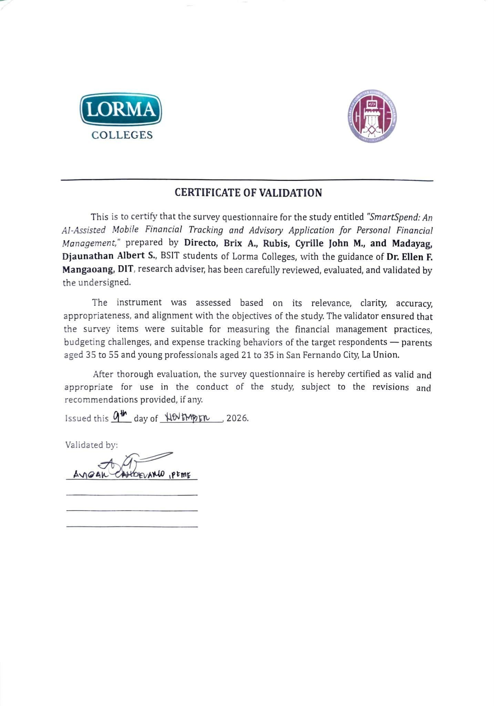
APPENDIX E
Content Validation Certificate (FHS Formula and Literature)


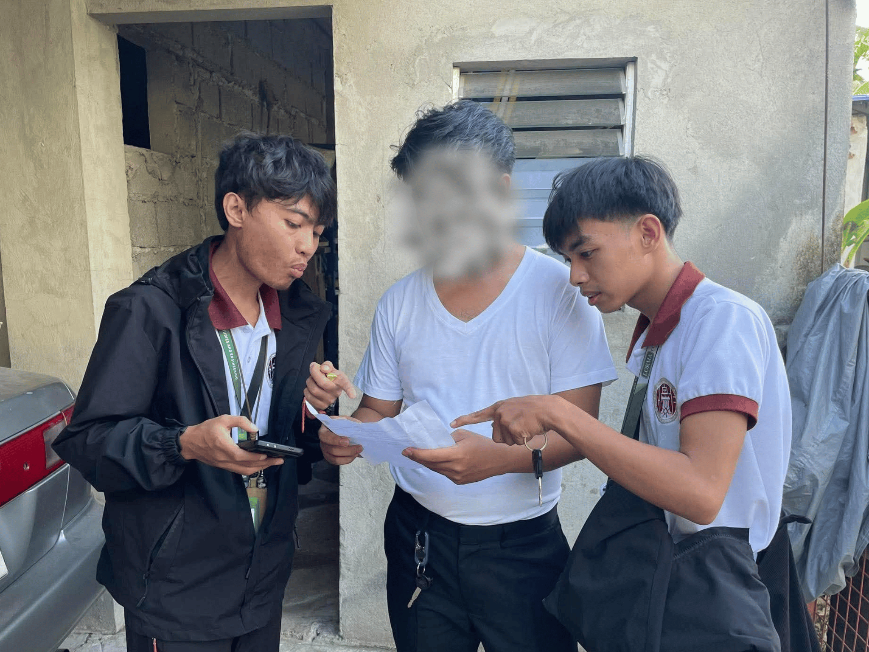 | 
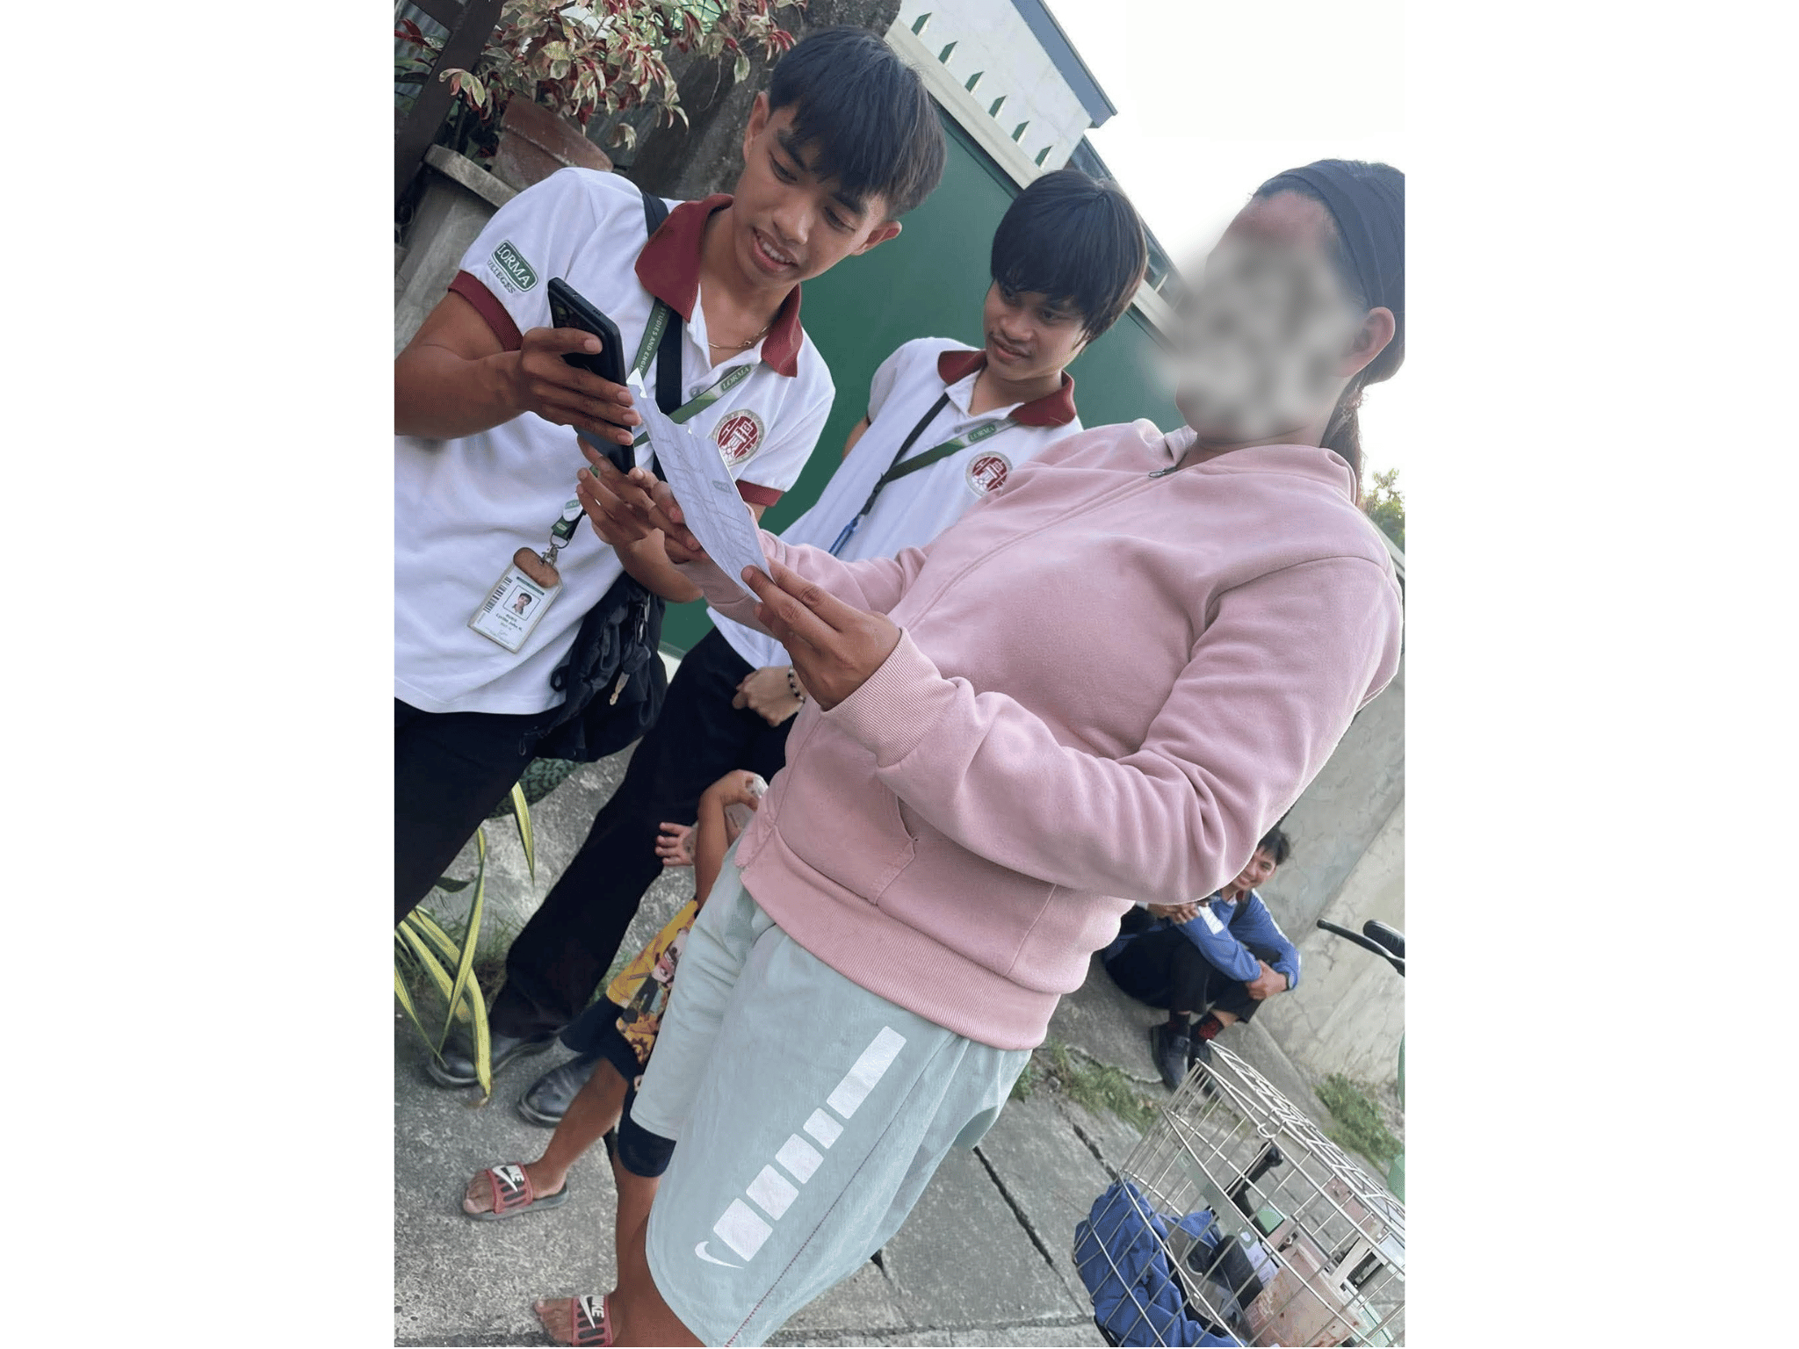 | 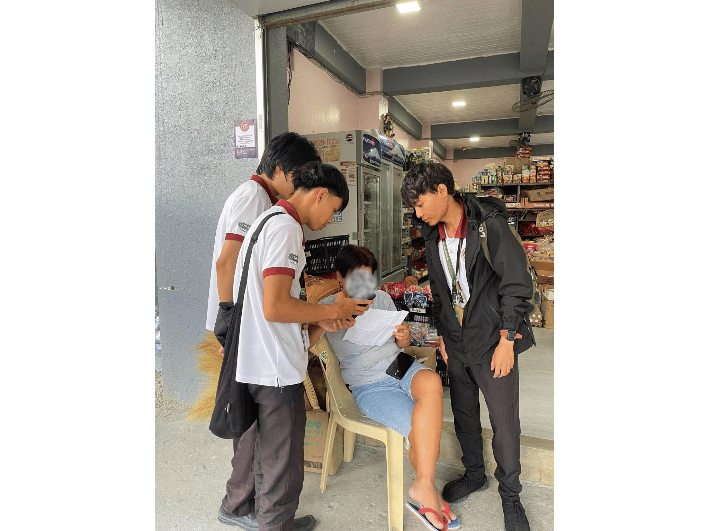
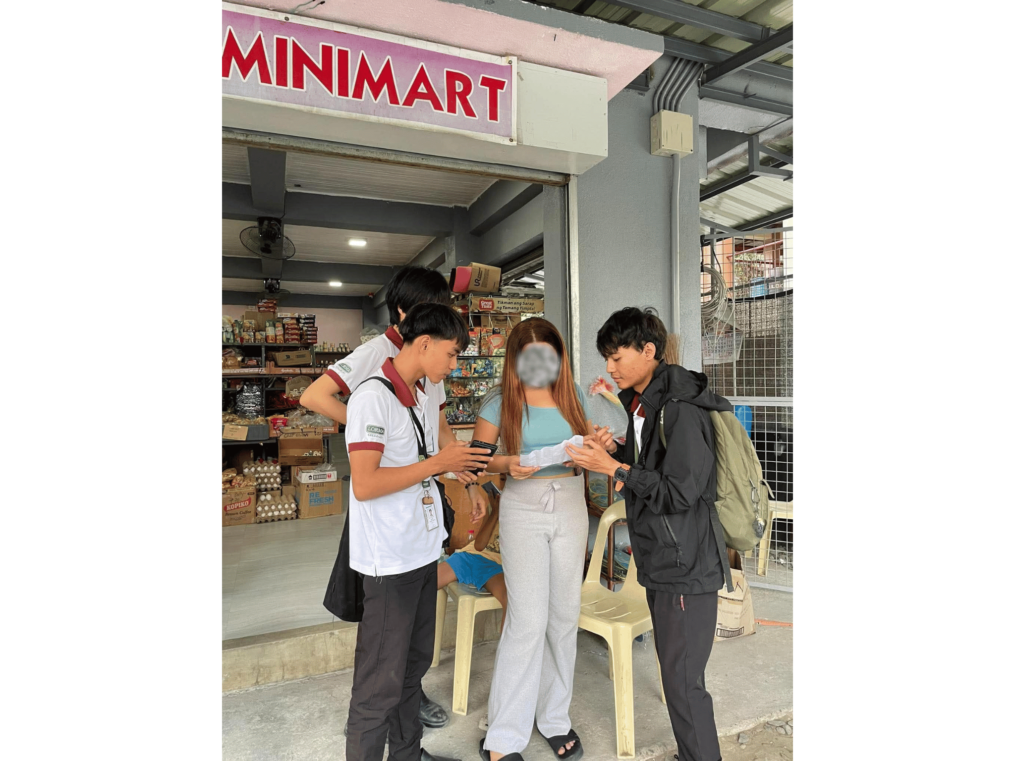 | 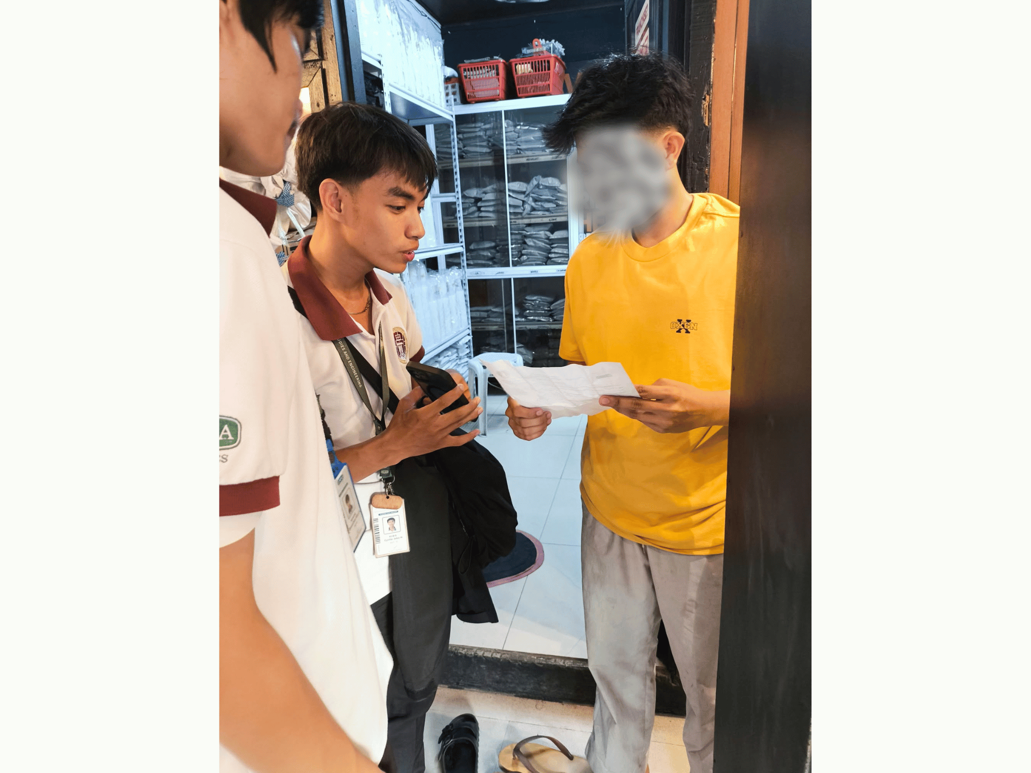

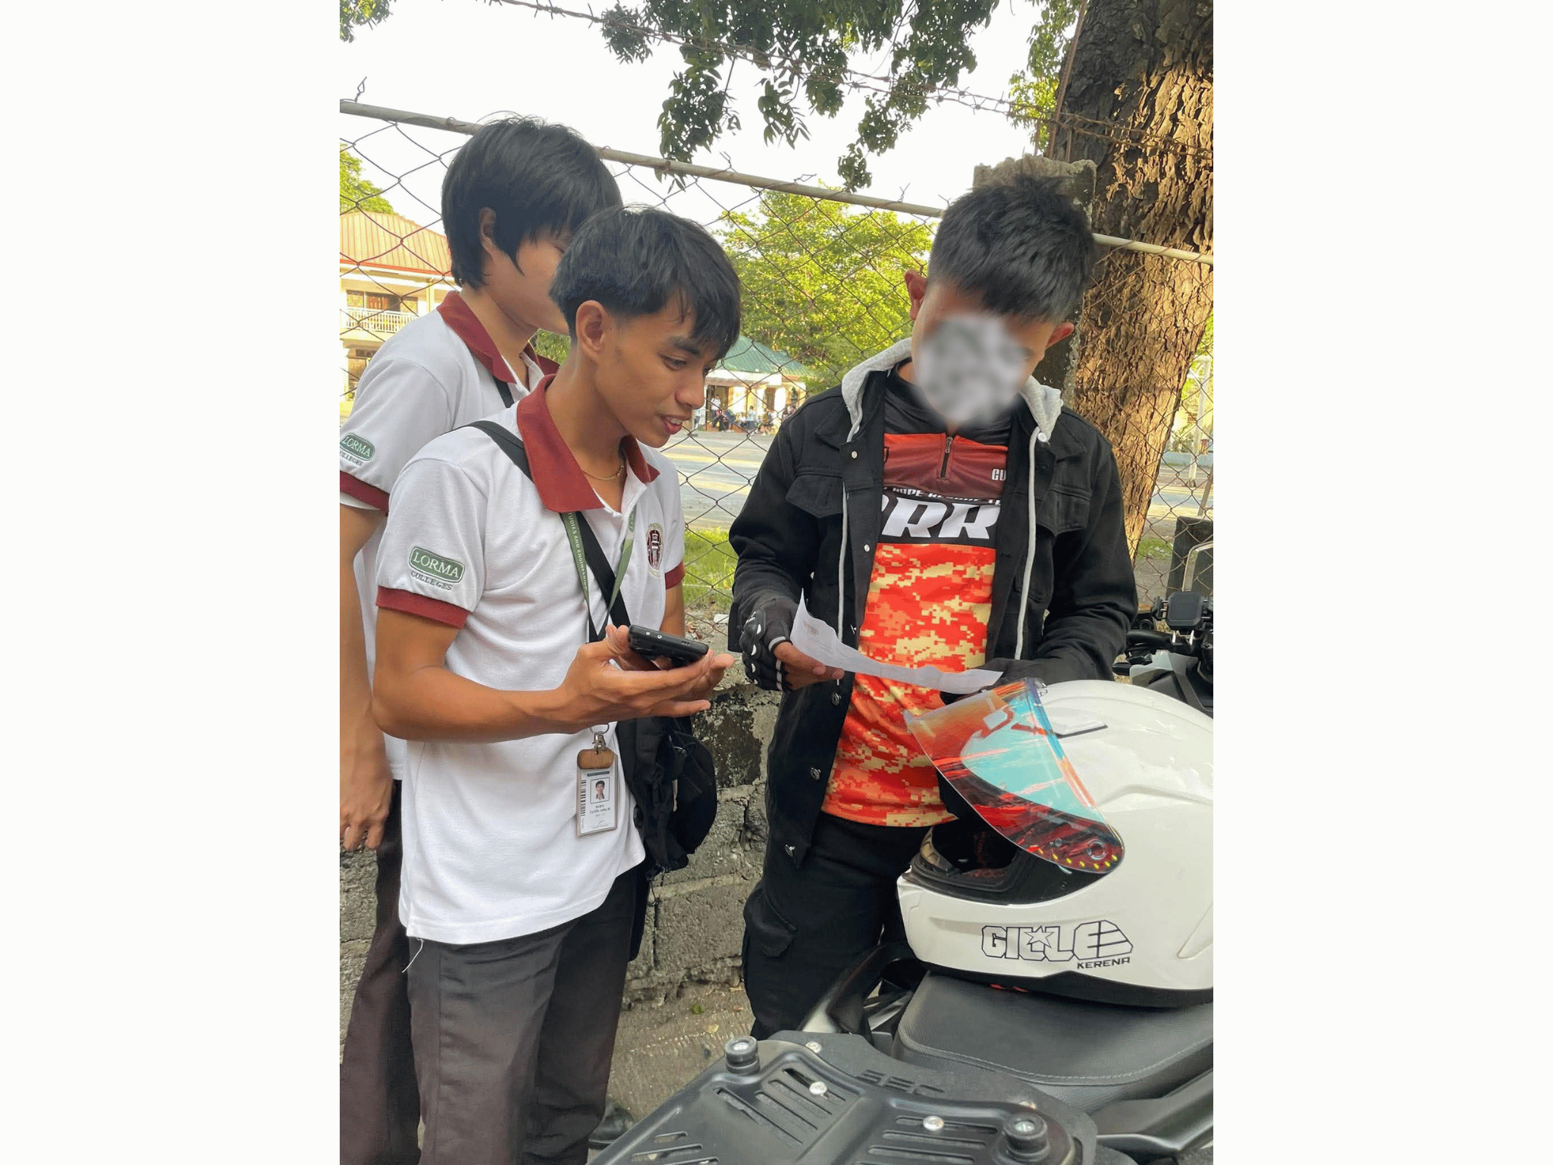 | 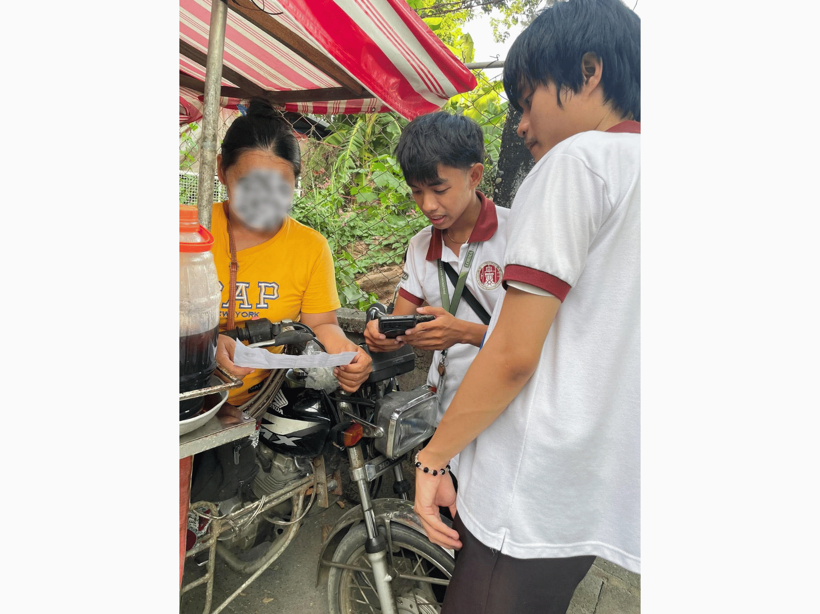
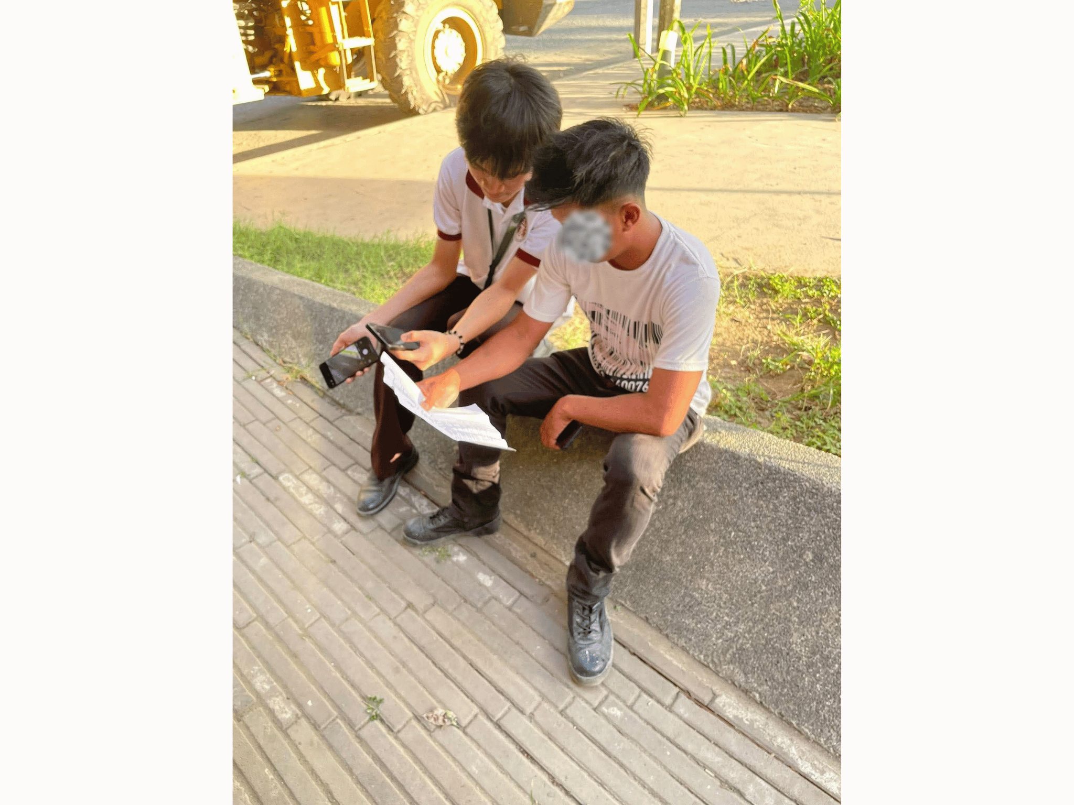 | 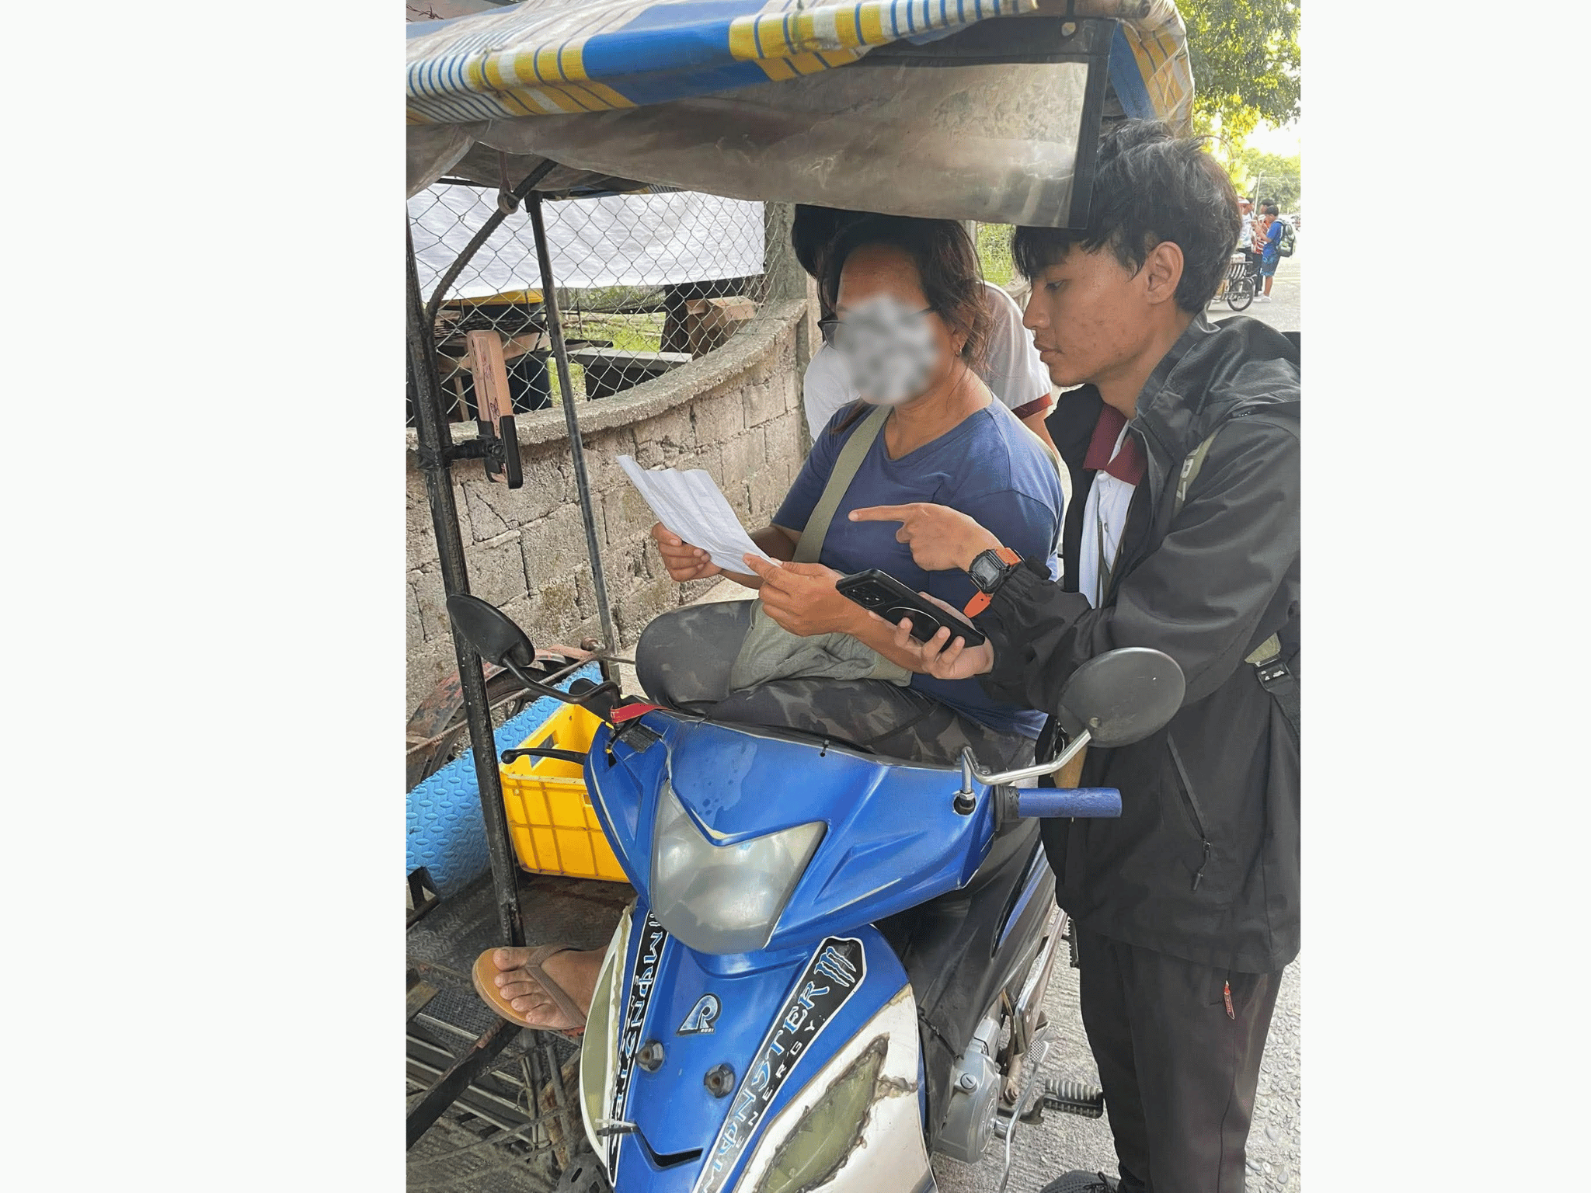
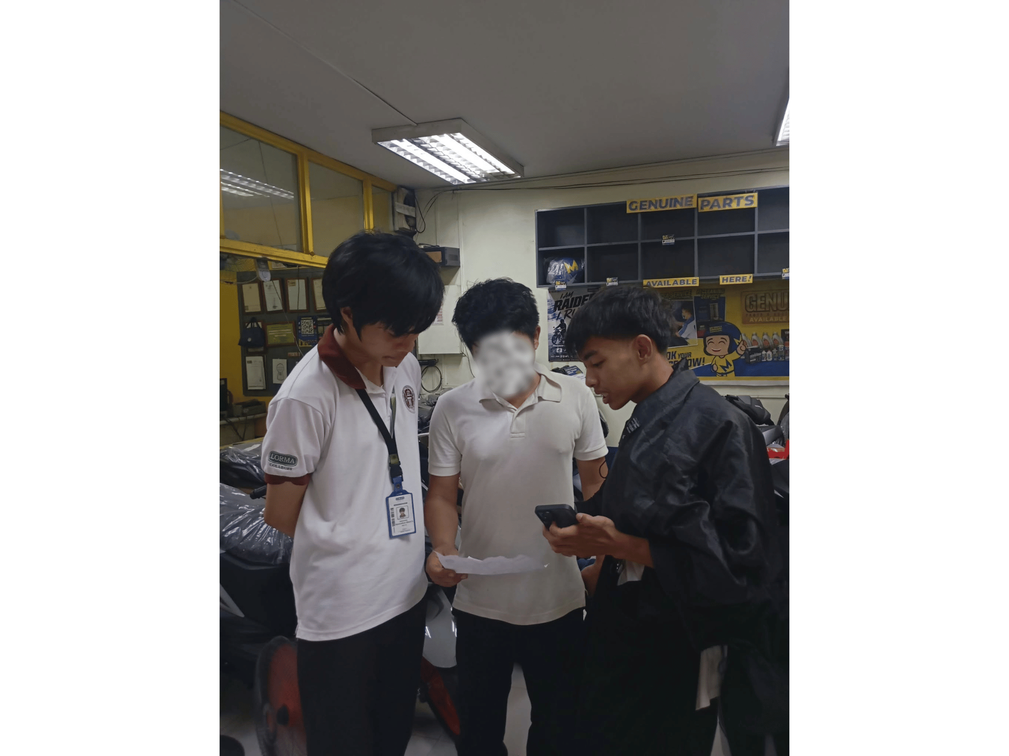 | 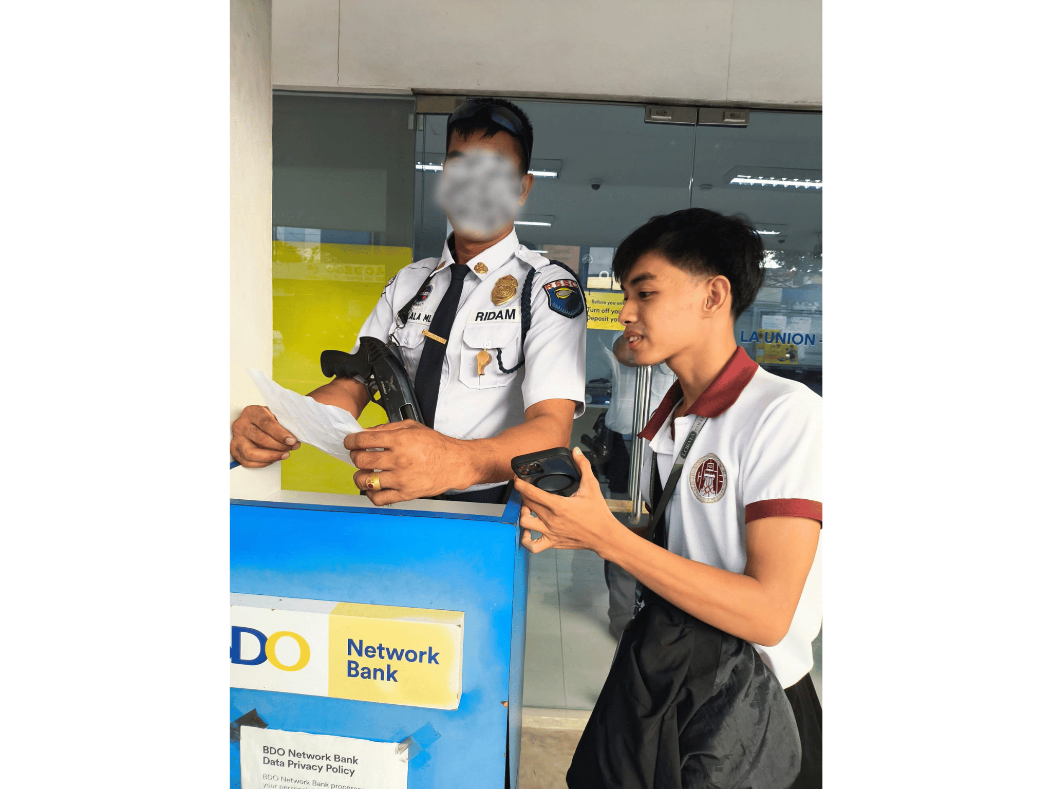

CURRICULUM VITAE

BRIX A. DIRECTO
I. PERSONAL INFORMATION
Address : Bagbag, Quirino, Bacnotan, La Union Date of Birth : September 4, 1999 Email Address : brix.arquisal@lorma.edu
II. EDUCATIONAL BACKGROUND
Tertiary (2018–2020, 2023–Present) Lorma Colleges Bachelor of Science in Information Technology (Undergraduate)
Secondary (2012–2018) Stella Maris Academy General Academic Strand (GAS)
Primary (2006–2012) Quirino Elementary School / Bitalag Integrated School
III. AWARDS/CITATIONS/RECOGNITIONS RECEIVED N/A
IV. WORK EXPERIENCE
Statistics Researcher | Philippine Statistics Authority (PSA) – ULAFO 2025
Freelance IT Technician / Programmer | Self-Employed 2019 – Present
Remote BPO Agent 2020 – 2022
Office Assistant | Bureau of Fire Protection (Work Immersion) 2018
V. ELIGIBILITY N/A
VI. SEMINARS/TRAININGS ATTENDED
National Conference on Computing, Engineering, and Business | 2019 Basic Japanese Language Training | 2021–2022 Work Immersion Program – Bureau of Fire Protection | 2018 Various Online Web Development Trainings
VII. INVOLVEMENT IN RESEARCH/RESEARCHES CONDUCTED
Capstone 1: SmartSpend: AI-Assisted Financial Tracker (Capstone Project)


CYRILLE JOHN M. RUBIS
I. PERSONAL INFORMATION
Address : Cantingan Street, Brgy. Quinavite, Bauang, La Union, Philippines 2501 Contact Number : 09761285890 Email Address : cyrillejohn.rubis@lorma.edu Date of Birth : August 26, 2005 Place of Birth : City of San Fernando, La Union
II. EDUCATIONAL BACKGROUND
Tertiary (2023–Present) Lorma Colleges Bachelor of Science in Information Technology (Undergraduate)
Secondary — Senior High (2021–2023) Sacred Heart School – Senior High School
Secondary — Junior High (2017–2021) Sacred Heart School
Elementary (2011–2017) Saints Peter and Paul Learning Center
Kindergarten (2010) Saints Peter and Paul Learning Center
III. AWARDS/CITATIONS/RECOGNITIONS RECEIVED
College Level: N/A
Senior High School: Conduct Awardee With Honors Best in Science Beacon Photo Journalist
Elementary: Best in Filipino Best in Science Conduct Award Makatao Award Makakalikasan Award Sportsmanship Award Inter-School Athlete (Basketball)
IV. WORK EXPERIENCE
Service Crew | McDonald's 2025
Photographer | Studio at 301 2022–2023
Freelance Photographer/Videographer | Self-Employed 2021–2023
V. ELIGIBILITY N/A
VI. SEMINARS/TRAININGS ATTENDED
Food Safety Seminar | 2025 Global Conference on Robotics and Artificial Intelligence Technologies (GCRAIT) | 2023 CCSE Startup Seminar | 2023 Beacon Officers Seminar | 2022

VII. INVOLVEMENT IN RESEARCH/RESEARCHES CONDUCTED
Organic Lip Balm and Its Benefits and Effectiveness (2021–2022) Effects of Mobile Devices on Grade 10 Students During the Pandemic Crisis (2022–2023) Capstone 1: SmartSpend: AI-Assisted Financial Tracker (Capstone Project)


DJAUNATHAN ALBERT S. MADAYAG
I. PERSONAL INFORMATION
Address : Raois, Bacnotan, La Union Contact Number : 09456219766 Email Address : djaunathan.madayag@lorma.edu Date of Birth : March 8, 2005 Nationality : Filipino
II. EDUCATIONAL BACKGROUND
Tertiary (2023–Present) Lorma Colleges Bachelor of Science in Information Technology (Undergraduate)
Secondary — Senior High (2021–2023) Lord of Zion Divine School Accountancy, Business and Management (ABM) Strand
Secondary — Junior High (2017–2021) Lord of Zion Divine School
Primary (2010–2016) Bacnotan Central School, La Union

III. AWARDS/CITATIONS/RECOGNITIONS RECEIVED
College Level: Dean's Lister | 2023–2025 (Lorma Colleges)
Senior High School: With Honors | 2021–2023 (Lord of Zion Divine School)
Junior High School: With Honors and With High Honors | 2020–2021 (Lord of Zion Divine School)
IV. WORK EXPERIENCE
Office Assistant | Municipal Office – Accountancy Department, Bacnotan, La Union (Work Immersion)
V. ELIGIBILITY N/A
VI. SEMINARS/TRAININGS ATTENDED
StartUp Seminar | 2023 Introduction to Computing | 2024
VII. INVOLVEMENT IN RESEARCH/RESEARCHES CONDUCTED
Return on Investment (ROI) Analysis of Business Operations (2021–2022) Financial Management and Salary Allocation in Business Operations (2022–2023) Cost Analysis and Profitability of a Business Enterprise (2022–2023) Capstone 1: SmartSpend: AI-Assisted Financial Tracker (Capstone Project)

